
CONCEPT DESCRIPTION: PAF Receiver Assembly
Document number WP2-XXXXXXXXXXXXXXXX
Revision
Author
Date
Status Draft

Name | Designation | Affiliation | Date | Signature
Additional Authors
Submitted by:
Accepted by:
Approved by:

DOCUMENT HISTORY
Revision | Date Of Issue | Engineering Change Number | Comments
A | - | - | First draft release for internal review
B | - | -
C | - | -

DOCUMENT SOFTWARE
 | Package | Version | Filename
Wordprocessor | MsWord | Word 2007
Block diagrams
Other

ORGANISATION DETAILS
Name | SKA Program Development Office
Physical/Postal  Address | Jodrell Bank Centre for Astrophysics  Alan Turing Building  The University of Manchester  Oxford Road  Manchester, UK  M13 9PL
Fax. | +44 (0)161 275 4049
Website | www.skatelescope.org

TABLE OF CONTENTS
1 Introduction 6
1.1 Purpose of the document 6
2 References 6
3 Context 8
3.1 SKA Hierarchy 8
3.2 Role of PAF Receiver Assembly in the Dish Array 9
4 Physical Description 9
4.1 Gain block subassembly with switched filters 10
4.2 RF over fibre subassembly 11
4.3 Receiver gain calibration subassembly 12
4.4 Analog-to-digital conversion subassembly 13
4.5 Digital Filterbank and Beamformer subassemblies 13
4.6 Digital transmission within the Filterbank/Beamformer 14
4.7 Digital Optical Transmitter 14
5 Requirements 14
5.1 Functional Requirements 15
5.1.1 Imaging dynamic range 15
5.1.2 Feed flexibility (dishes) 15
5.1.3 Rapid installation 15
5.1.4 Minimising maintenance cost 16
5.1.5 Reliability 16
5.1.6 Electromagnetic compatibility 16
5.2 Non-Functional Requirements 17
5.2.1 Mass manufacture 17
5.2.2 Operating cost 17
5.2.3 Maximising A/T per unit system cost 17
5.2.4 Maximising survey speed per unit cost (PAFs) 17
5.2.5 System Environmental Requirements 17
5.2.6 System Operational and Quality Requirements 18
6 Technical Progress to Date 18
7 Cost Estimates 18
8 Plans for Further Development 18

LIST OF FIGURES
Figure 1 Dish Array Hierarchy 8
Figure 2 PAF Sub-system Hierarchy 9
Figure 3 Direct sampling at RF but with switched narrowband anti-aliasing filters 10
Figure 4 Switched narrowband anti-aliasing filters for direct sampling at RF 10
Figure 5 RF over Single-mode Fibre 12
Figure 6 Topology of a cross connected beamformer 14

LIST OF TABLES
Error! No table of figures entries found.

LIST OF ABBREVIATIONS

Ant. Antenna
CoDR Conceptual Design Review
DRM Design Reference Mission
EoR Epoch of Reionisation
EX Example
FLOPS Floating Point Operations per second
FoV Field of View
LNA Low Noise Amplifier
Ny Nyquist
OH Over Head
OTPF Observing Time Performance Factor
Ov Over sampling
PAF Phased Array Feed
PrepSKA Preparatory Phase for the SKA
RFI Radio Frequency Interference
rms root mean square
SEFD System Equivalent Flux Density
SKA Square Kilometre Array
SKADS SKA Design Studies
SPDO SKA Program Development Office
SSFoM Survey Speed Figure of Merit
TBD To be decided
Wrt with respect to

Introduction
This document describes the concept for the PAF receiver assembly , which has been developed by the PAFSKA consortium and is applicable to the SKA Dish Array.
The PAF receiver system encompasses (ADD DIAGRAM – pedestal electronics, coarse filterbanks, inter component connects etc).
Many elements of the PAF receiver assembly are under development by PAFSKA partners for use in new or upgraded radio telescopes, e.g. Apertif (ASTRON), CSIRO (ASKAP), …
These new PAF-based systems provide direct input to the SKA PAF concepts described here. In addition there is direct SKA-related R&D ongoing within the contributing partners as also described in the details which follow.

Purpose of the document
The purpose of this document is to describe the sub system, including the following information.
- Its context within the Dish Array Element
- Discussion of the SKA requirements that the sub system will address
- Physical description of the sub system
- Target specifications
- Description of interfaces
- Details of technical progress to date
- Cost estimates for production in SKA quantities
- Details of further plans up to production readiness

References
- SKA Science Case
- The Square Kilometre Array Design Reference Mission: SKA-mid and SKA-Lo v 0.4
- Science Operations Plan
- System Interfaces
- Environmental requirements (natural and induced)
- SKA strategies and philosophies
- Risk Register
- Requirements Traceability
- Logistic Engineering Management Plan (LEMP)
- Risk Management Plan (RMP)
- Document Handling Procedure
- Project Dictionary
- Strategy to proceed to the next phase
- WP3 SKA array configuration report
- WP3 SKA site RFI environment report
- WP3 Troposphere measurement campaign report
- SKA Science‐Technology Trade‐off Process (WP2‐005.010.030‐MP‐004)
- SKA Monitoring and Control Strategy WP2-005.065.000-R-001 Issue Draft E
- “The Square Kilometre Array”, Peter E. Dewdney, Peter J. Hall, Richard T. Schilizzi, and T. Joseph L. W. Lazio, Proceedings of the IEEE Vol. 97,No. 8, August 2009
- System Engineering Management Plan (SEMP) WP2-005.010.030-MP-001Reference 3
- SKA System Requirement Specification (SRS)
- SKA IP Policy Document

Context

3.1 SKA Hierarchy
The SKA Systems Engineering Management plan has defined multiple layers of hierarchy:
L7: SKA User
L6: System
L5: Element
L4: Sub-System
L3: Assembly
L2: Component
L1: Part
Although not explicitly stated in the SEMP, the hierarchical approach has the advantage of breaking down the complexity of the system. Each layer is only concerned about its own functionality and its interface to the immediately adjacent layers.
Within the hierarchical scheme, the Dish Array is defined at the element level deriving its requirements directly from a subset of System level requirements. In turn, the sub-system level allows the Dish Array element to be partitioned further into Level 4 functionality, comprising the Dish, PAF and Single Pixel Feed sub systems. Single Pixel Feeds are further divided into Feed Payload and Receiver assemblies at level 3. Introducing these layers of hierarchy ensures that the complexity of the system is broken down such that an individual layers only have to deal with their relevant perspective of the system.
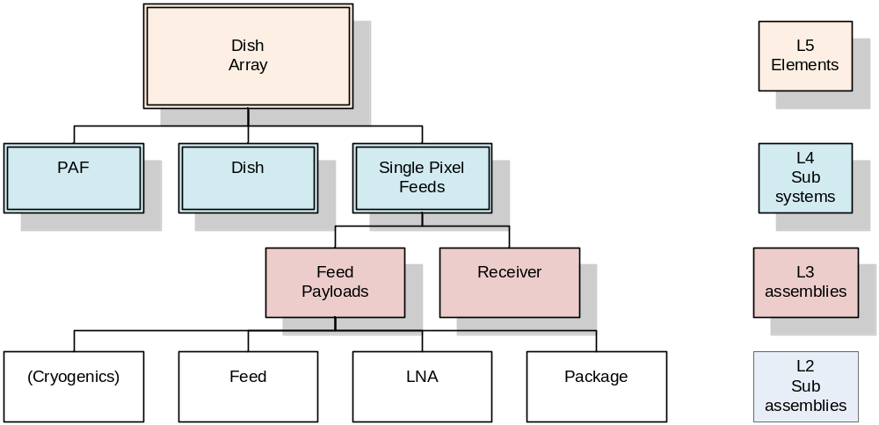
Figure 1 Dish Array Hierarchy
This document describes one family of options for the level 3 system assembly, the PAF receiver.

3.2 Role of PAF Receiver Assembly in the Dish Array
This concept is applicable in the case where PAF receivers are implemented as part of the SKA’s dish feed array.
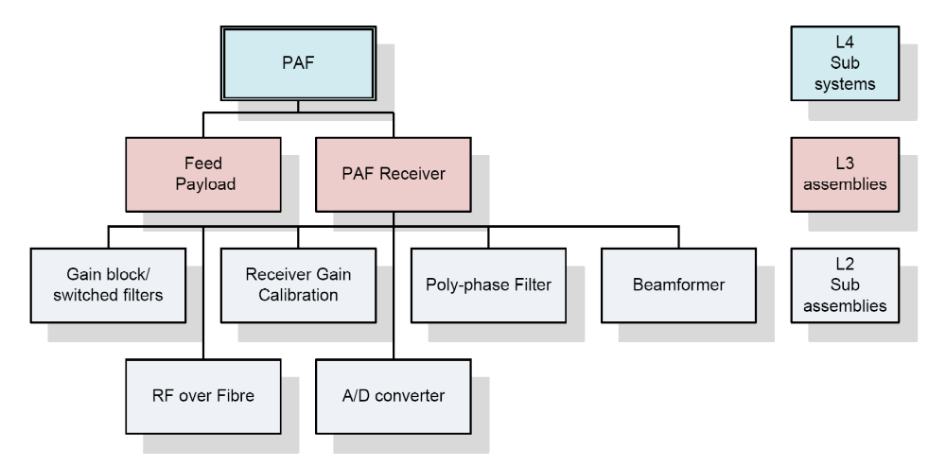
Figure 2 PAF Sub-system Hierarchy
The PAF receiver with RF-over-fibre signal transmission of the signals is a receiver assembly that can be used with a variety of phased array feed sub systems delivering multiple beams, wide FoV and high survey speed. RF signals from a number of antennas could be sent either to the central site, or to centralised RFI shielded “bunkers”, where the signals are digitised and digitally processed. The PAF receiver with RF-over-fibre signal transmission specifically addresses the functional and non-functional requirements for a high survey speed for the SKA; many of these requirements are unique and go far beyond what has previously required for ground based radio astronomy.

Physical Description
Provide a description of the proposed sub system, with diagrams, CAD drawings, photographs etc. Include details of how the sub system will interface with other parts of the Dish Array.
This PAF receiver assembly concept includes the following components;
- A set of two switched anti-aliasing filters to cover the whole 600 – 1500 MHz RF band,
- Transmission of the RF over fibre to the Analog-to-digital conversion block,
- Gain calibration to correct for minor variations in gain and phase of the RF channels,
- Analog-to-digital conversion using the EV8AQ160 or similar,
- Digital processing in the Filterbank/Beamformer, and
- Digital transmission within the Filterbank/Beamformer using optical fibre.
Figure 3 is a block diagram showing the key components and where they will be housed.
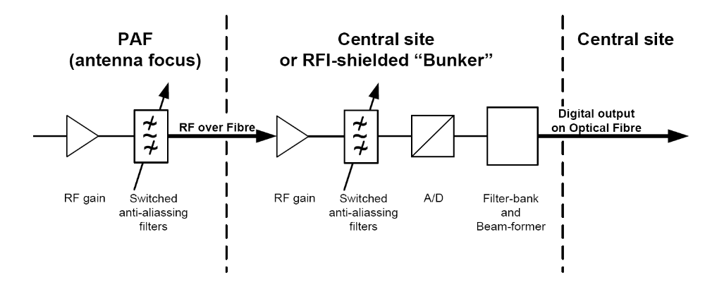
Figure 3 Direct sampling at RF but with switched narrowband anti-aliasing filters
A feature of this option is that it allows digitisation to occur up to, say, 10 km from the antenna. Thus the digitisation and digital processing of the signals from the antennas in the “core” and “inner” regions (for SKA Phase 1) could be at the central site; for antennas in the “Mid” region, the digitisation and digital processing of signals from one or more “clusters” of antennas could be centralised in RFI shielded “bunkers” and the resulting data trunked to the central site.
In the sections which follow we outline the component descriptions.

Gain block subassembly with switched filters
Cost competitive RF over Fibre systems are currently limited to at most octave bands due to second order intermodulation. The PAF covers more than an octave so this requires sub-octave band filters after LNA and RF amplification in the PAF, as illustrated in Figure 3. For each band this scheme provides a bandwidth that is comparable to that of an octave band single pixel feed. Indeed, it may be possible to substitute a PAF for one of the single pixel feeds envisioned for SKA Phase 1. For a wider bandwidth system it is suggested that the ADC needs to be located at the PAF – and this option is being explored separately.
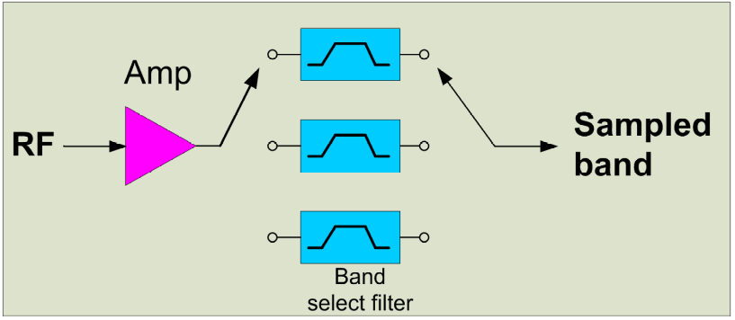
Figure 4 Switched narrowband anti-aliasing filters for direct sampling at RF
If the specification is for an IF bandwidth of the order of one half or one third of the RF bandwidth, we can use slower digitisers and reduce the amount of digital processing by processing only part of RF band at one time. We would filter and then sample the whole RF band using a number of switched, narrowband, anti-aliasing filters.
Note that the poly-phase filter that follows the ADC must operate at the clock rate of the ADC but at the output of the filterbank the frequency channels to be processed in the beamformer and correlator can be selected. In this design anti-aliasing filters with a relaxed specification for the transition band are used. This allows low cost filters to be used. After the filterbank frequency channels that are corrupted due to aliasing or excessive band slope can be discarded. The data at these frequencies is discarded at the output of the filterbank.
For a 600 – 1500 MHz RF band and an IF bandwidth of 400/600 MHz, we could use two switched narrowband anti-aliasing filters to cover the whole RF band and sample rates of 1100 or 1650 MS/s as listed in Table 1a. Alternatively, to achieve a wider IF bandwidth of 500/600 MHz, we could use the narrowband anti-aliasing filters and sample rates of 2500 or 1650 MS/s as listed in Table 1b.
RF Band | RF Band  (MHz) | RF Bandwidth  (MHz) | Sample rate  (MS/s)
Band 1 | 600 – 1000 | 400 | 1100
Band 2 | 900 – 1500 | 600 | 1650
Table 1a. Anti-aliasing filters required to cover the whole
600 – 1500 MHz RF band using two switched filters

RF Band | RF Band  (MHz) | RF Bandwidth  (MHz) | Sample rate  (MS/s)
Band 1 | 600 – 1100 | 500 | 2500
Band 2 | 900 – 1500 | 600 | 1650
Table 1b. Anti-aliasing filters required to cover the whole
600 – 1500 MHz RF band using two switched filters
With both of these options, the full 600-1500 MHz band is covered, but as the bandwidths of the two bands differ this may lead to under-utilisation of correlator and beamformer resources when band 1 is operational. For a wideband survey one ‘efficiency’ strategy might be to discard the lowest 100 MHz of band 2 data, and for HI surveys the uppermost 50 MHz . This reduces the total bandwidth in the beamformer and correlator to 450 MHz.

RF over fibre subassembly
RF over fibre solutions have existed for 30 years. The great challenge for the PAF is production of high stability, high spurious free dynamic range (SFDR) links with low input NF that can be manufactured within the budget. For SKA we suggest the target needs to be below AUD 200 per link including connectors.
Due to cost constraints Direct Modulation (DM) Direct Detection Intensity Modulation schemes using high spectral quality, low relative intensity noise (RIN), Direct Feedback (DFB) Single Mode Lasers (SML) at 1310 nm are seen as the best option for the optical transmitter. High linearity InGaAs/InP PIN diode photodetectors are used as the optical to electrical transducer.
SM Fibre loss at 1310nm zero dispersion wavelength is typically 0.35 dB/km with standard G652 9/125 um fibre. A link SFDR of 110 dB/Hz^{2/3} with 0dB optical loss is achievable [ref CASS SIG IPT private communications Feb 2011], this realises an SFDR of 52 dB over a 500 MHz band. Band transmission should be limited to sub-octave bandwidths, requiring bandpass preselection prior to the RFoF link, minimising generation of link 2nd order intermodulation products. Links may be extended to 10km (extra 3.5dB optical loss) with only marginal (7dB) reduction in dynamic range. The single mode architecture enables remote placement of the ADC and digital electronics up to 10km away from the antenna receptors greatly mitigating the risk of self RFI and reducing resident antenna hardware.
For a truly radio quiet site less dynamic range headroom is required, for 48 dB SFDR [500MHz] a 10 km link and a RFoF link output SNR of 20 dB, there is a 28 dB headroom margin. These figures are nominal based on low RIN DFB devices with good slope efficiency. A SFDR of approximately 50dB also presents a good compatibility with the SFDR obtainable from 8-bit ADC components. It would be possible to extend the link to 35 km, this would reduce the SFDR to 94 dB/Hz^{2/3} [ref Analog Optical Links, Cox p266], the headroom is thus reduced to 14 dB and presents a poorer utilization of overall ADC performance, but would still be viable in a radio quiet location. A shift from DFB devices at 1310 nm to devices at 1550 nm may be an option to increase SFDR over long spans but the effects of chromatic dispersion on distortion over SSMF would require a further proof of concept. The use of CWDM DFB devices in the 1550 nm band would enable greatly reduced fibre count and connector cost. The use of dispersion shifted SMF may be required.
Stabilities will be better than 0.013 dB and 0.16 deg phase at RF, averaged over any 60 sec period and less than 1.4 dB and 10 deg phase averaged over any 1 second period over all typical antenna movement and vibration situations [ ref CASS private communications Mar 2011].
On dish noise radiator calibration and astronomical wide FOV calibration techniques will be also be possible in the PAF antenna to maintain and correct for any instrumental variation in channel gain and phase.
Bias
SMF 0dB
PreAmp
PostAmp
600-1500MHz
Duoband
Z= 50Ω
Link NF < 20 dB
SFDR > 110 dB.Hz ^{2/3}
Link G > 0dB 18 dB
Flatness +/- 1 dB
Figure 5 RF over Single-mode Fibre
Single mode transmission of RF requires good Optical Return Loss (ORL), low back reflection connectors. Due to the large number PAF elements mass termination Multiple Parallel Optical (MPO) connectors are preferable. These can be used in 12 wide MPO configurations with Angled Physical Contact (APC) high ORL ~ 60 dB properties designed for single-mode ribbon fibre. Multiple MPO connectors can be mounted in the same connector shell making for rapid field replacement of the PAF. Single mode fibre loose tube could also be used rather than newer ribbon fibre based distribution but overall installation costs and connector maintenance would be expensive.
By 2017 the cost of the RF over fibre system is expected to be <AUD 200 per link including the post detection amplifiers and filters. This may also include new vertical cavity surface emitting lasers (VCSEL) based devices for 1310nm (and 1550nm) replacing DFB devices.
Current RFoF link cost breakdown as at Feb 2011
Item | Cost ea USD based on QTY 1000
DFB 1310nm Laser/isolator cw connector | $99
PIN Diode cw connector | $30
MPO connector at PAF | $20/per fibre core
Bias Control | $3
RF Gain Blocks | $8
Other discrete parts | $5
PCB Tx and Rx | $15
TOTAL | $180

Receiver gain calibration subassembly
Receiver gain calibration subassembly uses noise radiated from the dish surface or rim to measure and track the relative complex gains of the individual receiver channels from the low-noise amplifier through to the digitiser. A sample of the radiated noise is also digitised using a spare channel of the receiver. The sample of the radiated noise is correlated with the output of each of the RF channels to measure and track the relative complex gains of the individual receiver channels. The relative complex gains of the individual receiver channels are used to adjust the weights fed to the beamformer and thus compensate for channel gain and phase variations.
This calibration system will naturally measure, and compensate for, gain and phase variations in the RF electronics and in the RF-over-Fibre links – in bandwidths corresponding to the output channel bandwidth of the Poly-phase filters.

Analog-to-digital conversion subassembly
Examples of analogue to digital converters that meet the specification for a PAF are the EV8AQ160 and EV10AQ190 manufactured by E2V. Critical specifications for these are list below. Converters from other manufacturers are also suitable and as time progresses it is quite likely more options will become available.
For the example EV8AQ160 Analog-to-digital converter the critical specifications are:
- 8-bit;
- 7.2 ENOB;
- 4 samplers interleaved in one chip;
- Max. Sample rate in dual channel mode: 2.5 GS/s;
- Max. input Freq 2 GHz (typ.), 1.5 GHz (min.)

Max. Sample rate (MHz) | Input bandwidth (MHz) | interleaved
1250 | 600 | 1
2500 | 1200 | 2
5000 | 2000 | 4
Table 2. EV8AQ160 Analog-to-digital converter

Digital Filterbank and Beamformer subassemblies
The Digital Beamformer may include a poly-phase filter bank and processing to reformat the data prior to optical transmission from the antenna pedestal to the central site.
For the SKA beamformer, multiple processing boards are needed with cross connections to do the FX beamforming.
The analog data is digitised and then processed by a coarse filterbank. Each coarse filterbank system has a direct connection to each of the beamformer boards and for N beamformer boards the data on each connection carries data for 1/N of the frequency channels being processed.
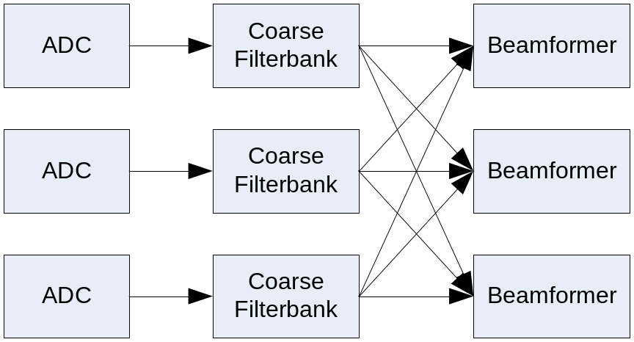
Figure 6 Topology of a cross connected beamformer

Digital transmission within the Filterbank/Beamformer
Digital data would be transported within the Filterbank/Beamformer shielded enclosure on optical fibre. Currently the cheapest method of transporting digital data over short spans, ie very short reach (VSR) on fibres is with the use of 12 fibre optical cables illuminated by 12 element optical transmitters such as the industry standard SNAP12 modules [SNAP12 specifications http://www.physik.uzh.ch/~avollhar/snap12msa_051502.pdf]. These are well suited to massively parallel data transfer applications such as BF to COR connects.
SNAP12 modules are expected to fall to under $100 each by 2017 (especially in the volumes required by SKA). Modal dispersion would limit the distance of these inherently multimode 50 um core 850 nm wavelength devices based on cheap VCSEL optical transmitters.
The use of appropriate fibre such as OM4 Corning Infinicor eSX+ extends the Effective Modal Bandwidth (EMB) from 500 MHz.Km to 4700 MHz.Km.

Digital Optical Transmitter
Beamformed outputs from the RFI shielded “bunkers” will the trunked to the central site using longer distance variants: 10BASE-ZR at 1550nm that will be capable of 80 km in standard G652 fibre. Again by 2016 we estimate that this will be available for ~AUD 2000 each (in volume).
The Data formatter for the output optical signal will be included in the Digital Beamformer. The Digital Optical Transmitter includes only the electrical-to-optical transducer and output optical connectors.
It is not clear how this overlaps with Signal Transmission and Networks (STaN) responsibilities.

Requirements
This section describes how the proposed sub system will address the requirements for the Dish Array, which are derived from the system requirements and ultimately the science requirements. These include both the functional and non-functional requirements. Some of the key requirements that need to be addressed are as follows.
- Imaging dynamic range
- Mass manufacture
- Operating cost
- Feed flexibility (dishes)
- Rapid installation
- Maximising A/T per unit system cost (i.e including signal transport, signal processing, computing etc.)
- Maximising survey speed per unit cost (PAFs)
- Minimising maintenance cost
- Electromagnetic compatibility

Functional Requirements
Describe which requirements are being addressed and how the proposed sub system is expected to meet them. For example, how will the octave band feed payload optimise the Dish Array pulsar observations capability, or how will the proposed PAF option optimise HI surveys?
Input/advice from Lisa?

Imaging dynamic range
High imaging dynamic range for PAFs is yet to be demonstrated. Imaging dynamic range is largely independent of the PAF receiver assembly concept but depends critically on the accuracy of the Receiver Gain Calibration subassembly..
Are there any compromises to DR which the receiver might implement (number of bit samplings?)

Feed flexibility (dishes)
Feed flexibility is not applicable to the PAF receiver assembly concept.
Agree, but perhaps more important to outline which components of the receiver system can be housed where & what flexibility there is (if any) of what to put where.

Rapid installation
Rapid installation is not applicable to the PAF receiver assembly concept.
No- but it is important that PAF receivers have accessible components which don’t take 4 days to extract one failed part. Modularity? Murandi ideas?

Minimising maintenance cost
The PAF receiver assembly will be designed to minimise maintenance costs.
How? What are the major traps we know of, is this very costly to mitigate?
What about looking at the closest commercial PAF (defence) who have solved this problem? (e.g. L3 products)
Do we put more $’s into expensive parts up-front? Build more self-test systems? Diagnose whilst the system is in the pedestal rather than having to remove cards/racks?
Tolerance to environment – heat, cold? Water/dew? (see 5.2.5 System Environmental Requirements)
Graceful degradation?

Reliability
The entire SKA receiver system will be field repairable to the level of tested sub-assemblies. No manufacturing, assembly or installation processes should be employed that would preclude field replacement of sub-assembly level systems or components.
The antenna reliability is defined by the observatory uptime requirement: no more than 1%?? of the antennas (of the complete SKA array) offline at any one time. This translates to a MTBF of 20000?? hours for the receiver system. The time to repair any single antenna fault should not exceed one day.
The SKA receiver system should be designed to require little hands-on maintenance. The interval between site visits by a technician to carry out any preventative or routine maintenance activity (including inspections) should not be less than 12 months ??? .

Electromagnetic compatibility
The PAF receiver assembly will be designed for electromagnetic compatibility.
And…?
What about mitigating self-interference? What are the noisy sources in this system? How can they be tested? Are they reliable or do they vary by T?
The SKA site has been chosen as it is virtually free of any terrestrial radio frequency interference The SKA receiver assemblies are to be designed to preserve the RFI environment at the SKA site, and this requires that all sources of RFI are to be shielded and made RFI-tight. As far as possible all components of the receiver are to be housed in RFI-tight cabinet(s). The cabinets are to meet the requirements of RFI/EMC shielding to provide electromagnetic attenuation better than 80 dB between 10 kHz and 1 GHz, tested as per IEEE-STD-299. All components of the receiver are to be certified by a qualified testing laboratory to meet the MIL-STD-461F standards ( RE102; In figure RE102-4 the limits for "Navy Mobile and Army" are applicable) over the frequency range 0.3 to 1.8 GHz.

Non-Functional Requirements
There are many non-functional requirements that will need to be met if the Dish Array is to operate successfully; a few of these are listed above. Describe here how some of the critical requirements are expected to be met. For example, how will it be mass-manufactured to minimise cost, whilst maintaining reliability; how will the maintenance cost be kept to a minimum?

Mass manufacture
The PAF receiver assembly will be designed to be mass-manufactured and to minimise the SKA system cost, including operation and maintenance.
ASTRON has much experience and many ideas to include here.
What about Murandi’s ideas?
Is there a case to chose one receiver architecture over another at this point? Is it easier to build I rather than 2?

Operating cost
The PAF receiver assembly will be designed to minimise the SKA system cost, including operation and maintenance.
Power? Which parts/components are power hungry? Temperamental?
The challenging conditions at the SKA site put a premium on minimising operational power consumption.

Maximising A/T per unit system cost
The PAF receiver assembly will be designed to minimise the SKA system cost, including operation and maintenance thus maximising A/T per unit system cost. (i.e including signal transport, signal processing, computing etc.)
Indicative figures – we don’t want to quote ASKAP verbatim but how about some projections?

Maximising survey speed per unit cost (PAFs)
The PAF receiver assembly will be designed to minimise cost thus maximising survey speed per unit cost.
This needs to be well argued at this point – need Lisa’s (and others) analysis here.

System Environmental Requirements
The receiver system will be designed for reliable operation at the site where the normal operating conditions are :
- Ambient T in the range -10 to +55 degrees C.
- The mean daily solar exposure ranges from 30 MJ/m2 (summer) to 13 MJ/m2 (winter).
Lightning protection is to be built into all components of the receiver system.
In average conditions, there is a significant amount of fine airborne dust (sand): all parts of the receiver system are to be suitably designed to prevent ingress into interior areas or mechanical parts, and minimise build-up on external surfaces.
All exposed parts of the receiver system are to be water-tight and vermin proof: In wildlife may destroy any material known to mankind.

System Operational and Quality Requirements
The challenging conditions at the SKA site put a premium on a number of design considerations for the SKA receiver system:
- Reliable and safe operation consistent with unattended operation.
- Every aspect of the receiver system is to be designed with the site restrictions in mind: The SKA needs to be able to maintain and repair the receiver equipment with limited engineering resources and personnel.

Technical Progress to Date
Give a brief description of development work to date, together with critical results where appropriate. More substantial reports on technical progress can be included as appendices.
Summarise PAF receiver technical progress to date viz. development of RF over fibre and direct RF sampling.
CSIRO to do.
Other partners – particular areas to contribute to be identified.

Cost Estimates
Provide initial cost estimates for manufacture of the proposed sub system in quantities applicable to the SKA phases 1 and 2.

Plans for Further Development
Describe the plans to further develop the proposed sub system up to the point where it can be mass manufactured. Include time lines and details of resources that will be available to carry out the work.
Summarise plans for further technical development of key technologies viz. development of RF over fibre and direct RF sampling.
Again – to be identified as soon as possible & start assembling this section.
Up until recently the cost of PAFs made them an unrealistic option on even single dishes let alone synthesis arrays. Both ASKAP, APERTIF and PHAD are developing first generation PAFs at this moment, but it is known that this generation of PAFs is too expensive for the SKA. However, with each generation of ADC, optical transmission and digital hardware the cost of the PAF will decrease. Even the work being done on Aperture Arrays will directly impact the cost of the PAF elements and RF electronics.
To achieve the full benefits of these advances it is necessary to build a new PAF system for each new generation of hardware. For example, new generation of digital hardware is available every 2-3 years and one of the direct effects is that the volume and cost of the digital hardware should approximately halve each generation. The cost of optical links also decreases with time. RF over fibre has already reached a cost and performance level such that it is a cheaper option than the co-axial cable RF transmission used, for example, in ASKAP. The lesson here is that a change in the cost of parts of the system can lead to a change in the optimum design concept. What the optimum design concept for SKA Phase 1 or 2 will be is not known at present.
It is only by building a complete PAF system with each generation of hardware that the strengths and weakness of the technology become apparent. It also highlights the areas were further innovation is needed. An example of this ongoing process is the Aperture Array developments where each generation of the array has shown cost reduction and improvements in performance. PAF development needs to follow the same approach as this. The advantage of the PAF is that the production of a single system which is then installed on a telescope such as ASKAP or APERTIF is sufficient to demonstrate its performance. This means the hardware cost needed to demonstrate the performance of each PAF generation will be some hundreds of thousand dollars and decreasing with time. The major cost will be the NRE needed for each generation.
Junk


