ATNF ATUC MEMORANDUM

To: ATUC
From: Lister Staveley-Smith
Date: June 2, 2004
Subject: Recent Astrophysics highlights

Some Recent Astrophysics highlights

1. The first-known double pulsar system

There are 1500 known pulsars, of which 100 are members of a binary system. Four of the binary companions are high-mass stars; six or seven are believed to be neutron stars; and the rest are low-mass white dwarf or helium-core companions. Of the neutron star companions, none have previously been detected as pulsars. This is not surprising, since the detected pulsars have millisecond periods, having been spun-up through accretion from the massive companion progenitor. The resultant companion neutron star would however have no accretion source, would not be spun-up, and would therefore not be expected to have a detectable lifetime in excess of 10⁷ yrs, compared with the ~10⁹ yr lifetime of millisecond pulsars. The chances of finding a double pulsar system are therefore low.

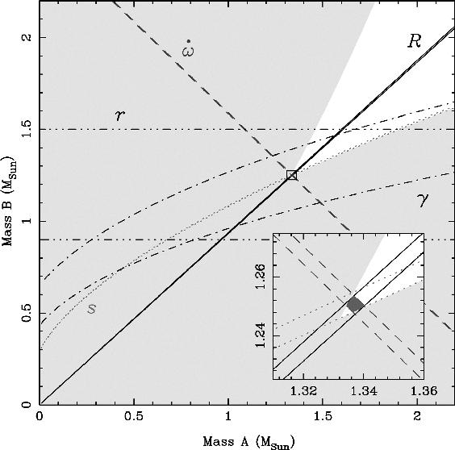

Figure 1: Constraints on the masses of the two pulsars J0737-3039A/B (Burgay et al. 2003, Lyne et al. 2004).

However, a Parkes intermediate latitude pulsar survey has recently discovered such a system, PSR J0737-3039A/B (Lyne et al. 2004, Science, 303, 1153). The A-pulsar has a period of 22 ms, whilst the B-pulsar has a period of 2.77 sec. Not only is this system remarkable for being the first known double, but it is also a highly relativistic system with an orbital period of 2.4 hrs and a precession of periastron of 17 deg/yr (Burgay et al. 2003, Nature, 426, 531). This is four times the rate of the Hulse-Taylor binary pulsar, and therefore allows more stringent tests of general relativity. A merger of the two pulsars is expected in 85 Myr, which is a third of the Hulse-Taylor merger time, and points to an overall neutron star-neutron star merger rate nearly an order of magnitude higher than previously believed in the Galaxy. This is of great interest for gravitational wave detection experiments. This system continues to be monitored with great interest at Parkes, the ATCA and other telescopes.

2. 20 GHz Imaging of the remnant of SN 1987A

The prospect of high-fidelity sub-arcsec imaging was one of the driving forces behind the development of the 20 GHz band for the ATCA. One source of considerable interest is SN 1987A, the remnant of which is ~1.5 arcsec across, making it too small for diffraction-limited imaging below 10 GHz at the ATCA, and too large for VLBI to be useful. The remnant of SN 1987A is presently undergoing an exponential increase in its X-ray luminosity (Park et al. 2004, astro-ph/0404145) as the shock front is starting to encounter dense cirumstellar material. A similar increase is seen in optical emission lines in HST data.

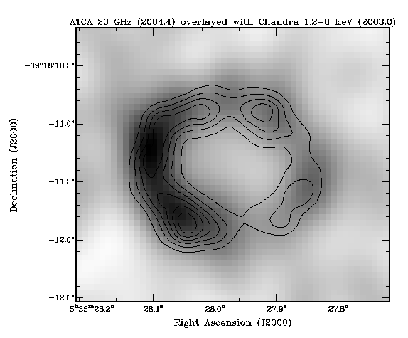
Figure 2: 2004 May ATCA image of the remnant of SN1987A at 12mm, overlayed with contours from the high energy 1.2-8 keV Chandra/ACIS band (Chandra image has no accurate astrometry, so the alignment is arbitary).

The first radio image at 12mm with a 6-km configuration (6D) was taken on 31 July 2003. The atmospheric stability was excellent. Two frequencies at 17.3 and 19.6 GHz were observed simultaneously. The integrated flux density of 25 mJy agrees with the extrapolation of the low-frequency flux densities. The final image (0.4 arcsec resolution), confirms the broad features seen in earlier super-resolved 3cm images. Moreover, a comparison of this, and later images, with Chandra/ACIS data (see Fig.2) shows both similarities and differences with the sites of thermal and non-thermal X-ray emission. Future analysis will hopefully reveal more about the relationship of post-shock thermal energy deposition and high-energy electron and ion acceleration mechanisms.

3. Circumnuclear Ammonia in NGC 253

The ammonia molecule is an excellent tracer of high density (>10⁴ cm⁻³) gas and is a useful tracer of molecular cores in the stages preceding gravitational collapse. Its metastable (J=K) inversion levels are excited by collisions and are much less affected by spontaneous emission than most other molecules. It is therefore an excellent interstellar thermometer. By comparing, for example, the (1,1) and (2,2) transitions at 23.65 and 23.68 GHz, the temperature distributions of cold and dense molecular gas can be obtained. Being so close in frequency, these transitions can be observed under virtually identical observing conditions and with similar spatial resolution. The advent of a high performance 12 mm system at the ATCA now allows such observations, and a large number of Ammonia proposals are being submitted.

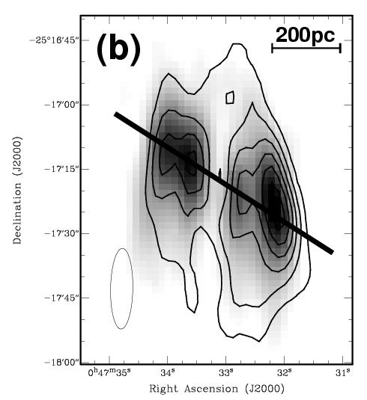
Figure 3: The integrated intensity from the (1,1) transition of Ammonia in the nucleus of NGC 253 with contours of (2,2) emission overlaid (J. Ott et al.).

The first extragalactic detection of Ammonia at the ATCA was obtained in the nucleus of the starburst galaxy NGC 253 (Figure 3). Ott and collaborators were able to detect a rotating nuclear ring (velocity spread ~250 km/s) and to map out its temperature distribution which varies from 40 K in the northeast to 80 K in the southwest. This appears to be the first interferometrically-derived temperature map derived for any extragalactic object using the Ammonia transition. Further observations of southern galaxies are planned.

4. A new spiral arm in the outer Milky Way

Using data from the Southern Galactic Plane Survey (SGPS), McClure-Griffiths and collaborators have discovered a possible distant spiral arm in the fourth quadrant of the Milky Way. The very distinct and cohesive feature can be traced for over 70º as the most extreme positive velocity feature in the longitude-velocity diagram (Fig.4). The feature is at a Galactic radius between 18 and 24 kpc and appears to be the last major structure before the end of the HI disk. The arm is quite well confined to the Galactic Plane, dropping at most 1 kpc below the Galactic equator. Over most of its length the arm is 1-2 kpc thick. A Galactic spiral model with pitch angle 9º is able to reproduce the data quite well and indicates that the new arm may be an extension of the Outer arm visible in the second quadrant. Observations for associated molecular emission are underway.
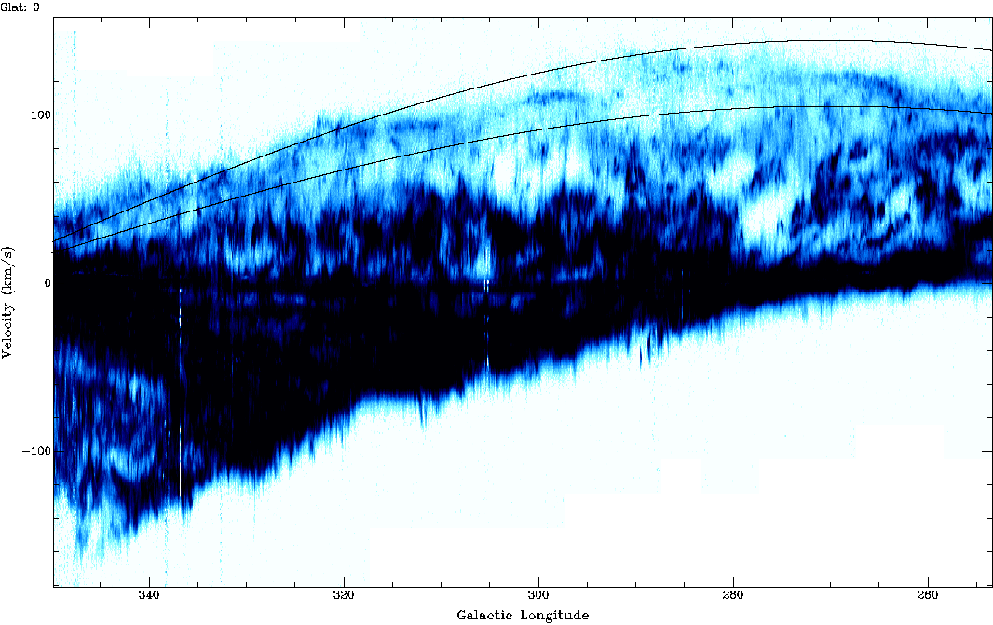

Figure 4: An HI longitude-velocity diagram from the Southern Galactic Plane Survey (Parkes and ATCA data). The extent of the new spiral arm is indicated by the thin solid lines (McClure-Griffiths et al. 2004, ApJL, 607, L127).

5. HIPASS deep galaxy catalogue

Following the production and analysis of the HIPASS Bright Galaxy Catalogue (Ryan-Weber et al. 2002, AJ, 124, 1954; Zwaan et al. 2003 AJ, 125, 2842; Koribalski et al. 2004, AJ, in press), the full HIPASS catalogue (HICAT) has now been published (Meyer et al. 2004, MNRAS, 350, 1195; Zwaan et al. 2004, MNRAS, 350, 1210). HICAT is the state-of-the art catalogue and represents the best that can be done with current analysis techniques. It consists of 4300 galaxies, and constitutes the largest blind HI survey by well over an order of magnitude. Reliability and completion have been thoroughly analysed through simulation and reobservation and release of this catalogue will be a valuable resource to the astronomical community. HICAT is also published electronically, and is available as a Virtual Observatory (VO) table accessible through a simple web interface. Enhancements to the HIPASS cube archive are also in place.

6. Ultra-relativistic outflows from compact objects

Several groups use radio telescope networks to monitor transient sources such as supernovae and Gamma Ray Bursts (GRBs). Berger et al. (Nature, 2003, 426, 154) used observations with the ATCA (which provided the first measurements) together with the VLA and Ryle telescopes to study the radio emission from GRB030329 which has been definitively associated with SN2003dh (Hjorth et al. Nature, 2003, 423, 847). This event is the first unambiguous link between supernovae and powerful GRBs, and confirms suspicions raised by the earlier, less powerful, event believed to have been associated with SN1998bw. Interpretation of the electromagnetic emission from GRBs suggests that beamed jet emission plays a large role. Berger et al. suggest a two-component model: a narrow ultra-relativistic jet (5º opening angle) responsible for the gamma ray and early optical emission; and a wide, mildly relativistic, component responsible for the radio emission and optical afterglow at later times.

The ubiquity of jet phenomena was also shown in an unrelated paper by Fender et al. (2004, Nature, 427, 6971) who used ATCA data (Fig.5) to discover an ultra-relativistic outflow in Circinus X-1, a neutron star accreting gas from within a binary stellar system. The measured velocity of the outflow is similar to the fastest flows in active galactic nuclei. Its strength is modulated by the rate of accretion of material onto the neutron star. Shocks are produced further downstream in the flow, which are themselves moving at mildly relativistic bulk velocities and are the sites of the observed synchrotron emission from the jet. Fender et al. conclude that black holes are not essential for the production of ultra-relativistic outflows.

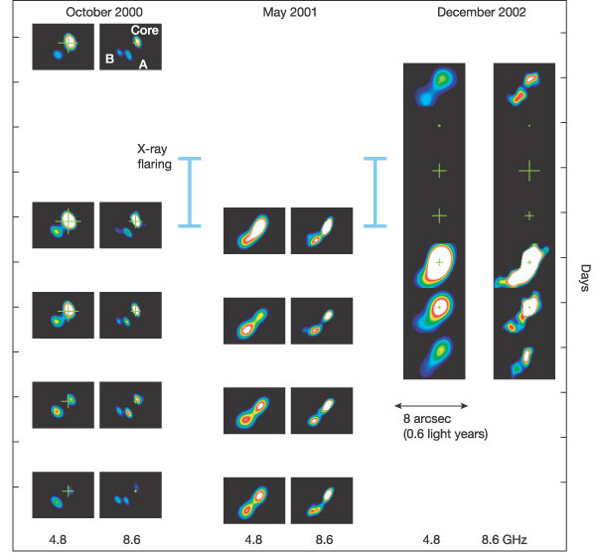

Figure 5: An ultrarelativistic outflow: sequences of radio observations of Circinus X-1 in October 2000, May 2001 and December 2002. At each epoch, observations were made simultaneously at 4.8 and 8.6 GHz. The apparent velocities associated with this expansion are 15c, indicating an underlying ultrarelativistic flow (Fender et al. 2004).

