Options for Supporting Single-dish Observations with the Tidbinbilla 34 m Beam Wave-Guide Antenna DSS-34.

Introduction
This document outlines options for supporting single-dish observations with the 34 m Beam Wave-Guide (BWG) antenna DSS-34. Two scenarios are explored: support of observations with existing (NASA) receivers and support in the event of additional radioastronomy receivers being installed.

Background
For many years NASA have been allocating observing time on the 34 m antenna DSS45 as well as the 70m for Host Country use. DSS-45 is restricted to the 3 and 13cm bands only and therefore there has been little interest in using this antenna as a single dish. Also less time is allocated than on the 70m (about 60h per year). However it has been used for some continuum VLBI observations as part of the LBA.
Earlier this year a co-axial 8.4 and 32 GHz system was installed on DSS-34. The main purpose of this new system is spacecraft tracking but it is also available for astronomy and may be of some limited use. Perhaps of greater interest to astronomers is that the design of the antenna permits the installation of many more receiver systems and room has been set aside for radio astronomy. With the upgrade of the ATCA and Mopra to 7 mm systems, a similar capability at Tidbinbilla will be important if LBA observations in this band are desired. (It is worth noting that the DSS-34 is designed to work up to frequencies of 100 GHz with the inner 26 m diameter illuminated). Therefore a request has been made for the DSN to switch radio astronomy allocations from DSS-45 to DSS-34.

Expected DSS-34 Time Allocation
On DSS-45, time was only allocated for periods of 12 h or more for VLBI and shorter periods were never requested. However for DSS-34 smaller allocations are useful for single-dish experiments and these have been requested. Short, 3 to 6h allocations tend to be more common as there are regularly gaps of this size between spacecraft tracking passes. At time of writing, allocations on DSS-34 for radioastronomy are yet to begin but it is reasonable to expect 100 to 200 h per year to be allocated for Host Country radio astronomy.

Sensitivity
Of the existing receivers on DSS-34, the 32 GHz system is probably the most interesting for single-dish observations. Specifications are as follows:
- Frequency range: 31800 to 32300 MHz
- Dual polarisation (RCP and LCP)
- 60% aperture efficiency
- Beam FWHM = 61”
- Tsys above atmosphere = 23 K. Typical Tsys with atmosphere = 30 K.
- SEFD = 160 Jy.
Compare the SEFD to an expected sensitivity of 5 ATCA antennas at 32 GHz of 150 Jy or the expected SEFD of Mopra of 750 Jy. This difference is due to the NASA receiver being a much narrower band than the ATNF systems.

The existing 32 GHz system may not be of great interest due to the small number spectral lines covered. Table 1 lists the known transitions within the band. In assessing the value of DSS-34 with the existing 32 GHz system and in the event that new receivers are installed, it is worth comparing sensitivity with Mopra. Table 2 shows a comparison in sensitivity and observing time for pointed as well as mapping/survey observations at 32 GHz and in the case that a wideband 7mm were installed on DSS-34 with similar receivers to Mopra. A similar comparison is shown in Table 3 for a hypothetical 3 mm system on DSS-34 assuming a similar system temperature and aperture efficiency to Mopra.

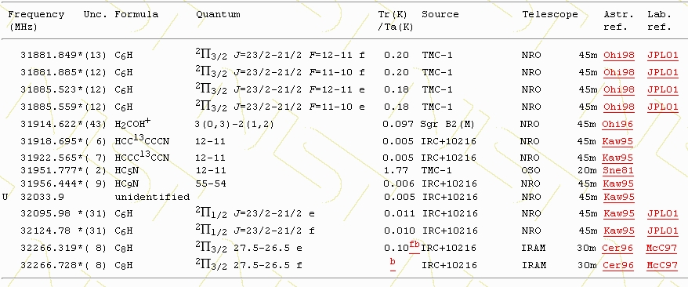
Table 1. Molecular transitions within the observing band of the DSS-34 32 GHz system (Lovas).

 | Mopra 7mm | DSS-34 32 GHz | DSS-34 7mm wideband
SEFD (Jy) | 750 | 160 | 314
1/t, single pointing | 1 | 22 | 6.2
1/t, mapping/survey | 1 | 9 | 2.6
Table 2. Comparison of Mopra sensitivity and observing time with DSS-34. Integration time comparisons are shown such that a larger number indicates greater efficiency. For example, for a single pointing at 32 GHz, DSS-34 would reach the same RMS as Mopra 22 times faster. Mapping/survey observations are less efficient than single pointing observations on DSS-34 because
the beam area is 2.4 times smaller than Mopra.

 | Mopra 3mm | DSS-34 3mm
SEFD (Jy) | 13500 | 9700
1/t, single pointing | 1 | 2.0
1/t, mapping/survey | 1 | 1.4
Table 3. Comparison of Mopra 3mm sensitivity and observing time with a hypothetical DSS-34 3mm system. Only the inner 26 m diameter of DSS-34 would be illuminated at 3mm. Integration time comparisons are shown such that a larger number indicates greater efficiency. Mapping/survey observations are less efficient than single pointing observations on DSS-34 because the beam area is 1.4 times smaller than Mopra.
Table 2 clearly demonstrates the efficiency of the 32 GHz system on DSS-34. 100 h at Tidbinbilla is equivalent to 90 days at Mopra for pointed observations, and 42 days for mapping/survey observations. Consequently, if there is good science to be done in this band, DSS-34 may play an important role.

A wideband 7 mm system at DSS-34 would be less advantageous with 100h at Tidbinbilla corresponding to 26 days (620 h) at Mopra for pointed observations or 11 days for mapping/surveying. Given the much higher availability of Mopra, a wideband 7 mm system at DSS-34 may not be particularly attractive for single-dish work. Mopra also has the advantage of the new MOPS correlator which allows several spectral lines to be observed simultaneously.

A 3 mm system on DSS-34 would have only a small improvement in observing efficiency over Mopra and given the limited time available on DSS-34, probably is not worth pursuing for single-dish work.

A 3 mm and a wideband 7 mm system on DSS-34 may be attractive for VLBI with the ATCA and Mopra. It seems unlikely that any other Australian antenna will be equipped with 7 mm or 3mm systems in the foreseeable future, so the addition of DSS-34 will provide the longest baselines in the array as well as allowing closure phase to be measured. DSS-34, Mopra and the ATCA may also form important elements of Global mm VLBI experiments with the VLBA, antennas in Japan and Korea, and perhaps with ALMA. It is also worth noting that the proposed Space VLBI mission VSOP-2 is expected to operate at 7mm and Australian antennas will play an important role.

Support
Currently ATNF provide a 0.5 FTE based in Canberra and is currently trialling a DA-style system to provide additional support from staff based in Marsfield. The additional observing support required for DSS-34 could come either through an expansion of the DA system or by basing another ATNF employee in Canberra. The former option seems the more likely.

The amount of additional support required for DSS-34 depends on the amount of time made available as well as demand. It is estimated that 100h of DSS-34 time would require support from an Epping-based DA at the level of 0.1 FTE. This estimate assumes 7 trips to Canberra per year per 100 h of observing time. (For a Canberra-based support person it is estimated that 0.07 FTE per 100 h would be required). In the discussion below it is assumed that the maximum allocation would be 200h per year.

Two scenarios are discussed below. The first is one where only existing NASA facilities are used while the second outlines the requirements for adding additional receiver systems to DSS-34. In both cases some initial work would be required to adapt existing observing software to the new antenna and its receivers.

1. Using Existing NASA Facilities
This option requires no additional hardware or engineering support as staff at Tidbinbilla maintain NASA-owned equipment. The only additional resources required are those to support the observations.

Additional resources required: 0.2 FTE maximum.

2. Additional Receiver Systems
There is no reason why non-NASA hardware could not be installed on DSS-34 for radioastronomy. A wideband 7 mm or a 3 mm system could be built and placed on the antenna. Funding and ATNF engineering resources would be required to achieve this and there would be the ongoing requirement for maintenance, some of which could perhaps be provided by Tidbinbilla staff, probably on a best-efforts basis. Observation support would be similar to that for Option 1 above.

Additional resources required: Design, construction, installation and testing of receiver(s) plus some ongoing maintenance. Observing support required: 0.2 FTE per year.

Recommendation
If the existing 32 GHz system is considered to be of value then ATUC may consider recommending that ATNF adopt Option 1. Given that the amount of DSS-34 time available to radioastronomy is unknown at present as is the level of interest from the community, ATUC may wish to consider making the following recommendation to ATNF:

That DSS-34 time is made available at the next Announcement of Opportunity and that ATNF support observations on a best-efforts basis with current resources. 70 m time should take the highest priority.

