ATNF ATUC MEMORANDUM

To: ATUC
From: Lister Staveley-Smith, Bärbel Koribalski
Date: 25 November, 2005
Subject: Recent Astrophysics Highlights

Recent Astrophysics Highlights

1. THE GALACTIC SUPERSHELL GSH 242-03+37
A new survey of the Milky Way with the Parkes telescope has produced its first major discovery, a massive shell of expanding gas powered by an energy equivalent to 30 supernova explosions. The Galactic All-Sky Survey (GASS) commenced its two-year program of observations at the Parkes telescope earlier this year and, almost immediately, an energetic Galactic supershell (GSH 242-03+37) was found by McClure-Griffiths and collaborators. The radius of the shell is 560 parsecs, or 1800 light years. It is believed that fragmentation of such shells may explain the significant population of compact neutral hydrogen clouds recently discovered by the Greenbank telescope. The results are due to be published in the Astrophysical Journal (McClure-Griffiths, Ford, Pisano, Gibson, Staveley-Smith., Dedes & Kalberla 2005, astro-ph/0510304).
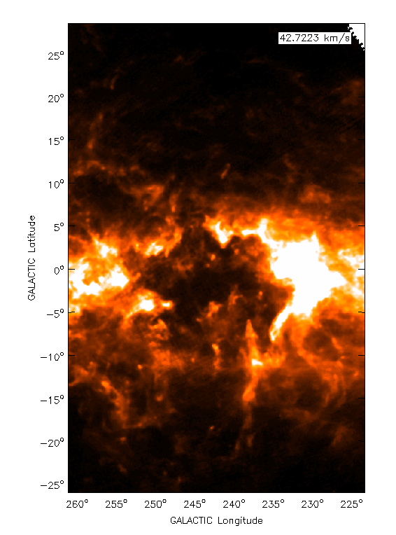

Figure 1: HI image of the Galactic supershell GSH 242-03+37 at a velocity of 42 km/s. The supershell is one of the largest in the Galaxy, with a diameter of over 1 kpc. New HI data from the Galactic All-Sky Survey (GASS) reveal that the supershell is broken at both the top and bottom. Large billowy filaments extend from the shell in the disk for more than 1.5 kpc into the lower Galactic halo (McClure-Griffiths et al. 2005 ).

2. PULSAR PROPER MOTION
A new study of pulsar polarization properties with the Parkes telescope has led Johnston et al. to the important discovery that the rotation axis of pulsars is consistently aligned with the direction of their motion. This provides confirmation of the so-called “rocket effect”, where an offset magnetic dipole causes the stars to accelerate along their rotation axis. The results are due to be published in the Monthly Notices of the Royal Astronomical Society (Johnston, Hobbs, Vigeland, Weisberg, Kramer & Lyne 2005, astro-ph/0510260).

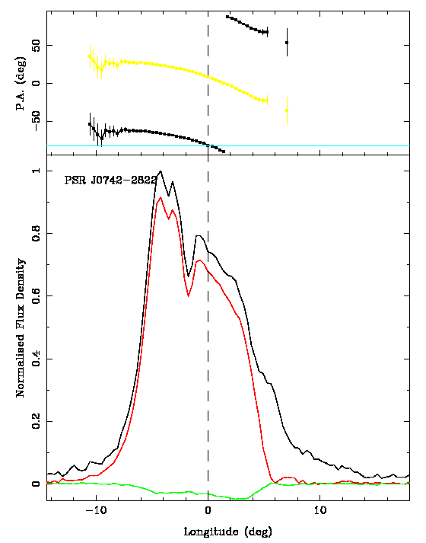
Figure 2: Example of a pulsar whose velocity axis and rotation axis are aligned. The bottom panel shows the pulsar profile in total intensity (black), linear polarization (red) and circular polarization (green). The dashed line marks the location of the rotation axis. The top panel shows the position angle of the linear polarization (black dots). The angle of the velocity vector on the sky is shown by the light blue line. At the location of the rotation axis, the position angle of the velocity vector and the linear polarization are the same, showing the angles are aligned (Johnston et al., astro-ph/0510260).

3. ALFA RELATIVISTIC BINARY
A young, highly relativistic binary pulsar (J1906+0746) has been found in the ALFA pulsar survey. The expected gravitational wave coalescence time is only 300 Myr and the rate of orbital periastron advance is 8 deg/yr. Geodetic precession may already have been seen. This may be a younger version of the double pulsar system but intensive searches for radio pulses from the companion have been unsuccessful so far. Parkes observations were used to provide “pre-discovery” data and timing and polarimetry observations. The paper has been submitted to the Astrophysical Journal (Lorimer, Stairs, Freire, Cordes et al. 2005).
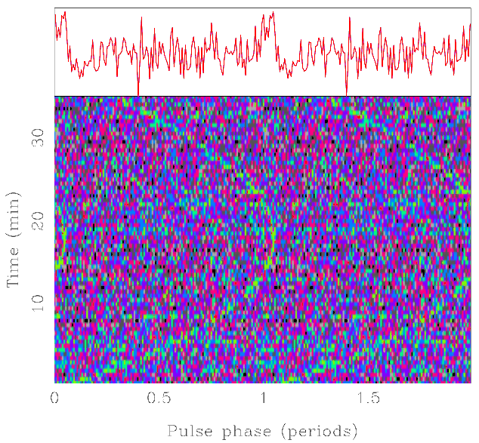

Figure 3: Phase-time diagram of the binary pulsar J1906+0746 as observed with Parkes at 1374 MHz in August 1998. While radio interference prevented a detection at the time, the pulsar was quite visible with the hindsight of the Arecibo detection made in September 2004 (Lorimer et al. 2005, submitted).

4. GIANT DOUBLE RADIO SOURCES
Using the Sydney University Molonglo Sky Survey (SUMSS) Saripalli et al. (2005) compiled a complete sample of double radio sources with projected linear sizes larger than 0.7 Mpc (assuming H_{o} = 71 km/s/Mpc), significantly enhancing the database of known giant radio sources. Using ATCA high-resolution imaging as well as low-resolution optical spectra from the 2.3m ANU telescope, they determine an abundance of (215 Mpc)⁻³ at the sensitivity of the survey. The results are published in the Astronomical Journal (Saripalli, Hunstead, Subrahmanyan, & Boyce 2005, AJ 130, 896).

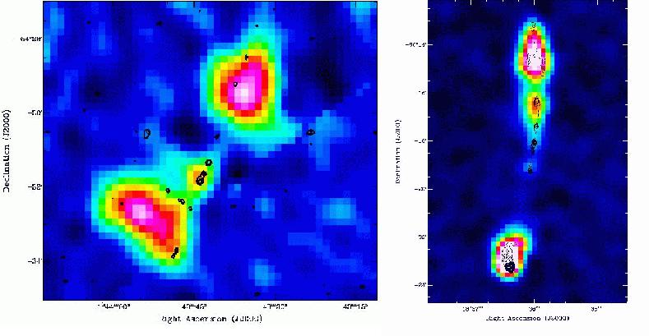

Figure 4: Examples of re-starting giant radio galaxies (Saripalli et al. 2005). SGRS J0143-5431 (left) lies at a redshift of z=0.1791 and has a size of 1 Mpc, while SGRS J1336-8019 (right) lies at z = 0.2478 and has a size of 2.5 Mpc. The figures consist of SUMSS 843 MHz images (color) and ATCA 1.4 GHz images (contours). The central core and two inner ‘lobes’ are the signatures of re-starting radio galaxies.

- PRECESSING JETS
Subrahmanyan et al. (astro-ph/0509275) have imaged, using the Compact Array, the SUMSS giant radio source SGRS J0515-8100. The radio lobes of this galaxy are very wide and are hypothesised to have been created as the result of a highly variable and intermittent jet whose axis direction also varied significantly. As the host galaxy also shows evidence for an ongoing galaxy-galaxy interaction, it is possible that this interaction is also sufficient to perturb the inner accretion disk that produces and sustains AGN jets. If this applied to other radio galaxies with similar morphology, it may be unnecessary to invoke the coalescence of black holes, and that the corresponding event rates predicted for gravity wave detection experiments may be overestimated. The results are due to be published in the Astrophysical Journal (Subrahmanyan, Hunstead, Cox & McIntyre 2005).

6. ASTROMETRY IN THE SOUTHERN SKY
Very Large Baseline Interferometry (VLBI) 8.4 GHz observations of a total of 111 radio sources in the southern hemisphere (Ojha et al. 2005) reveal their structure at milli-arcsecond resolution. Only the most compact of these sources are useful for astrometry. The imaging results represent the most extensive VLBI survey of southern hemisphere International Celestial Reference Frame (ICRF) sources to date. The results are published in the Astronomical Journal (Ojha, Fey, Charlot, Jauncey, Johnston, Reynolds, Tzioumis et al. 2005, AJ 130, 2529).

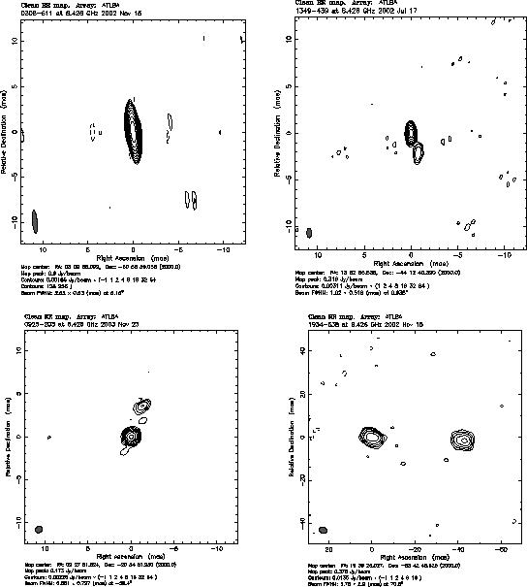

Figure 6: Radio sources at 8.4 GHz with structures ranging from very compact (index 1, top left) to extended (index 4, bottom right). Sources with index 3,4 should be avoided in astrometric and geodetic VLBI experiments (Ojha et al. 2005).

- ¹²CO (1-0) MOLECULAR RIDGE IN THE LMC
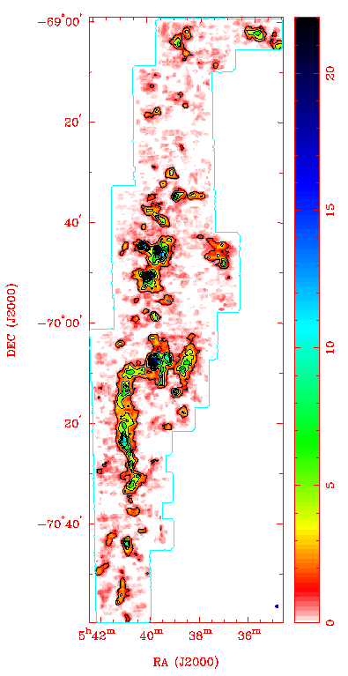
The molecular ridge near 30 Doradus, which is the most prominent feature in the Large Magellanic Cloud (LMC), has now been mapped with the Mopra 22-m telescope in the ¹²CO(1-0) line at 115.271 GHz. The map consists of about 120 fields, each of which was observed for two hours. The extent of the molecular ridge southwards from 30 Dor allows us to trace the effects of the radiation field on the molecular gas. A first analysis of the H₂/CO conversion factor (X-factor) by Ott et al. revealed a gradient from 2.5 X_{Galactic} near 30Dor to Galactic values at the very tip of the ridge. The results are currently being prepared for publication (Ott, Wong, Muller, Hughes, Pineda, et al. ).

Figure 7: ¹²CO(1-0) Mopra map of the molecular ridge south of 30 Doradus in the Large Magellanic Cloud (by Ott, Wong, Muller, Hughes, Pineda et al.)

Awards
An international team of scientists, including the ATNF’s Dr David Jauncey, has won a prestigious international award for their involvement in the Japanese VSOP/Halca orbiting radio telescope. The International Academy of Astronautics (IAA) presented its Laurels for Team Achievement award to the team of 15 scientists and engineers from five countries at the 56th International Astronautics Congress in Fukuoka, Japan, on October 16. The IAA created the Laurels for Team Achievement award in 2001 to recognise extraordinary performance and achievement by a team of scientists, engineers and managers in the field of astronautics. The previous winners of this award are the Russian Mir Space Station Team (2001), the US Space Shuttle Team (2002), the Solar and Heliospheric Observatory (SOHO) Team (2003), and the Hubble Space Telescope Team (2004).The International Academy of Astronautics was founded in 1960 in Stockholm, Sweden, by Theodore Von Karman, a pioneer of space exploration. Its objective is to foster the development of astronautics for peaceful purposes and to recognise individuals who have distinguished themselves in a related branch of science or technology.

An article by Rosslyn Beeby appeared on p.3 of the Canberra Times on October 14.
See: http://www.csiro.au/index.asp?type=mediaRelease&id=192award.

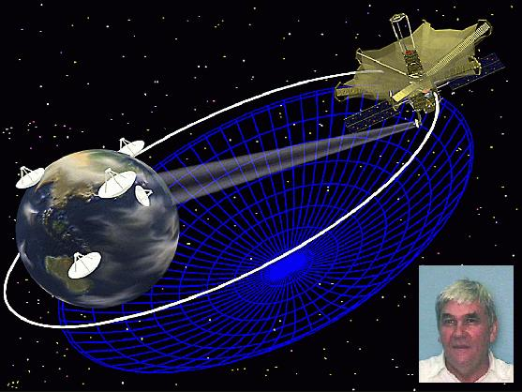

Figure 6: Artist impression of the Japanese VSOP/Halca radio telescope VSOP orbiting the Earth. Insert (bottom right): picture of Dave Jauncey (CSIRO, ATNF).

