ATNF ATUC MEMORANDUM

To: ATUC
From: Lister Staveley-Smith
Date: June 8, 2005
Subject: Recent Astrophysics highlights

Recent Astrophysics highlights

- Magnetar Formation and Hyperflares

An explosion (hyperflare) from the surface of a distant (>6 kpc; McClure-Griffiths & Gaensler 2005, astro-ph/0503171) highly-magnetised (10¹⁵ G) neutron star SGR 1806-20 occurred on December 27, 2004. The hyperflare had an energy of around ~10⁴⁶ ergs with most of the energy being emitted at high energies. Even the Earth's ionosphere was disturbed, with significant changes in the propagation of radio communication signals being apparent. The results of several weeks of ATCA monitoring of the expanding shock wave have been published in Nature (Gaensler et al. 2005; Nature, 434, 1104). The luminosity of the radio after-glow was 500 times larger than the only other detection of a similar source and the nebula was seen to expand at 0.25 c.

A separate study of the ISM around the magnetar 1E 1048.1-5937 using the ATCA/Parkes Southern Galactic Plane Survey (SGPS) has also recently been made (Gaensler, McClure-Griffiths et al. 2005, ApJ, 620, 95). This study has able to establish that the hydrogen shell, GSH 288.3-0.5-28 with a diameter of 35×23 pc (for a distance of 2.7 kpc) and an expansion velocity of ~7.5 km s⁻¹, was centered on 1E 1048.1-5937. It was concluded that the progenitors of magnetars are likely to massive stars in the range 30-40 solar masses, which is more massive than normal pulsar progenitors.

- The Galactic All-Sky Survey (GASS)

As previously reported, the next generation Parkes HI multibeam survey, the Galactic All-Sky Survey (GASS; McClure-Griffiths et al.), continues. Its aim is to survey the southern sky in a similar manner to HIPASS, but concentrating on HI emission at Galactic velocities and at velocity resolutions of ~1 km/s instead of the 18 km/s of HIPASS. The scientific goals are to study the disk-halo interface, to study the nature and origin of High-Velocity Clouds (HVC), to look for evidence of tidal streamers from infalling dwarf galaxies, and to map the distribution of the recently-discovered population of cold halo clouds. A third of the southern sky has already been covered in the first pass. Fig.1 shows an image between RA 4hrs and 8 hrs reduced using new data reduction algorithms implemented by Mark Calabretta. To facilitate the survey, the multibeam correlator power was doubled by combining the original multibeam correlator with the (pulsar) wideband correlator and by outfitting the outer 6 beams of the multibeam receiver with narrow band 8 MHz filters. Two Ph.D. students now have aspects of the GASS project as the primary part of their thesis projects

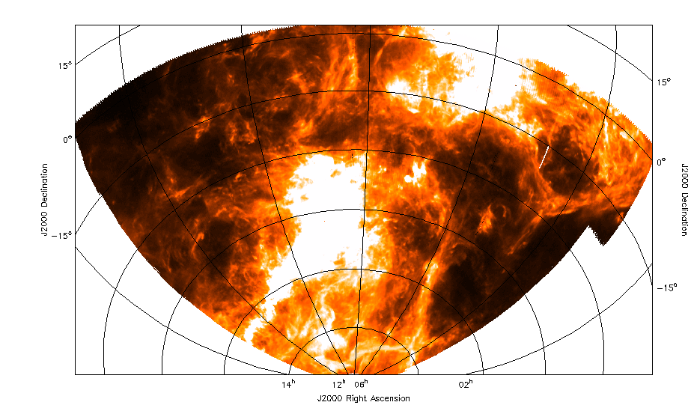

Figure 1: Image at LSR velocity 5 km/s of a portion of the sky from the Galactic All-Sky Survey (GASS) at Parkes (McClure-Griffiths et al.). Data taken in March 2005.

- Upper Atmosphere Winds on Titan

On January 14, 2005, the Parkes telescope, other CSIRO telescopes and other large radio telescopes (notably the NRAO Robert C. Byrd Green Bank Telescope) were the first to be able to confirm the successful landing of the ESA Huygens probe on Titan and to monitor its subsequent carrier transmissions for a period in excess of 2 hours. More significantly, this ground-based network was able to monitor the tiny shifts of the Huygens probe imposed by wind buffeting during its descent through the atmosphere of Titan. The winds were found to be weak near the surface and to increase slowly with altitude up to about 60 km, becoming much rougher higher up where significant vertical wind shear was deduced to be present (Bird et al. 2005, in preparation). The successful measurements were important for ESA due to the failure of the Doppler telemetry channel to Huygens' mothership, the NASA Cassini spacecraft. The immediate confirmation of successful landing, the rapid downloading of the descent data from CSIRO telescopes to the Netherlands via a leased 1 Gbps fibre, and the successful Doppler and VLBI measurements were a great success and may lead ESA to embark on other radio astronomy projects.

- An Ordered Magnetic Field in the Large Magellanic Cloud

Magnetic fields are hard to study in detail in the Galaxy because of projection effects and distance uncertainties. External galaxies are difficult to study in the pre-SKA era because of lack of adequate sensitivity. Therefore it was of some significance that Gaensler et al. (2005; Science, 307, 1610) were able to detect a coherent magnetic field in the LMC using the radio continuum data gathered as part of the HI survey of Kim et al. (1998). Figure 2 shows the distribution of polarized radio continuum sources in the LMC field and nicely demonstrates the detection, via Faraday rotation, of a significant magnetic field in the LMC. Detailed study indicates that the field is orderly and consistent with an axisymmetric spiral field of strength 1μG. Strong fluctuations in the field are seen at both small (<0.5 pc) and large (>100 pc) scales.

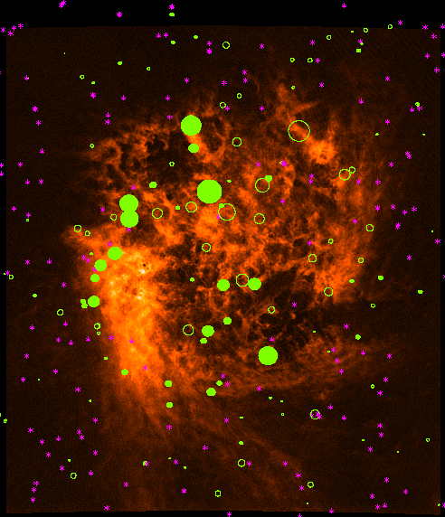

Figure 2: An Australia Telescope radio image of the Large Magellanic Cloud, overlaid with symbols indicating the magnetic field's strength and direction at various positions. The filled green circles indicate places where magnetic field is pointing toward us, while the open green circles show locations where it is directed away from us. The larger the circle, the stronger the magnetic field. The purple asterisks indicate positions where the magnetic field was too weak to be measured (Gaensler et al. 2005; Science, 307, 1610).

- LVHIS is alive and well!

The Low-Velocity HI Survey (LVHIS) aims to image with the Compact Array all galaxies in HI which are within 7 Mpc, south of Declination –30º, and which were detected by HIPASS. Together with a parallel H-band imaging survey being conducted on the AAT, the goals include the study of the Tully-Fisher relation, the velocity field, alignment, star-formation rate and environment of nearby galaxies, and the faint end of the HI mass function. Accurate redshift-independent distances (e.g. from the location of the tip of the Red Giant Branch) are available for ~40% of the LVHIS sample. Koribalski et al. have developed a pipeline and have imaged 33 galaxies in the past semester. They have also used the archive to image a further 10 with existing data. Galaxies will be imaged at resolutions of about 30” using the 1.5 km, 750-m and 352/367-m arrays. About 20% of the eventual target request of 1500 hrs has already been obtained. The reduced data from this survey are a valuable resource and images are uploaded to the LVHIS web site at www.atnf.csiro.au/research/LVHIS shortly after observations are concluded.

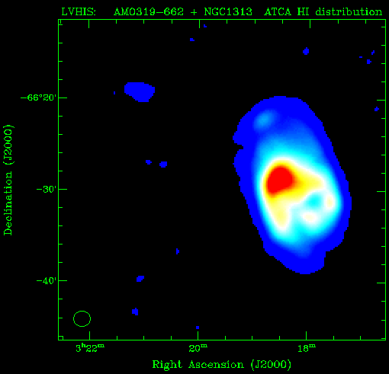 | 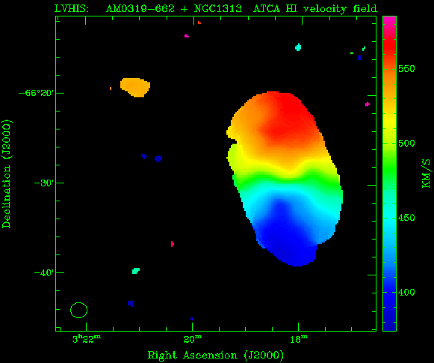

Figure 3a: Two LVHIS galaxies, AM0319-662 (HIPASS J0321-66) and NGC 1313 can be seen in (left) the column density image and (right) the velocity field. AM0319-662 is in the northeast of each image and is a dwarf irregular galaxy at a distance of 4 Mpc. NGC 1313 is a much larger disk galaxy in the southwest, about 20' away (Koribalski et al.).

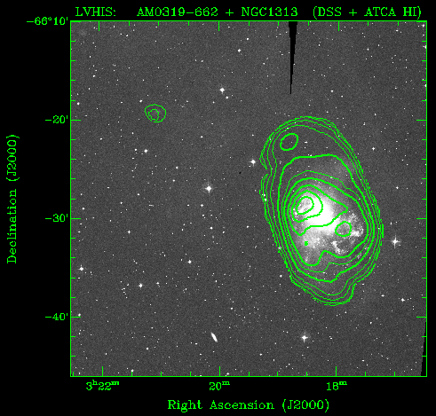

Figure 3b: The same field as Fig.3a with contours of HI column density superimposed on the DSS image at the bottom (Koribalski et al.).

More details on some of the above research, and research reported at previous ATUC meetings, can be found in the 2004 Annual Report and at the web address www.atnf.csiro.au/research/highlights/2004.

