
CONCEPT DESCRIPTION: PAF Receiver Assembly
Document number WP2-XXXXXXXXXXXXXXXX
Revision
Author
Date
Status Draft

Name | Designation | Affiliation | Date | Signature
Additional Authors
Submitted by:
Accepted by:
Approved by:

DOCUMENT HISTORY
Revision | Date Of Issue | Engineering Change Number | Comments
A | - | - | First draft release for internal review
B | - | -
C | - | -

DOCUMENT SOFTWARE
 | Package | Version | Filename
Wordprocessor | MsWord | Word 2007
Block diagrams
Other

ORGANISATION DETAILS
Name | SKA Program Development Office
Physical/Postal  Address | Jodrell Bank Centre for Astrophysics  Alan Turing Building  The University of Manchester  Oxford Road  Manchester, UK  M13 9PL
Fax. | +44 (0)161 275 4049
Website | www.skatelescope.org

TABLE OF CONTENTS
1 Introduction 7
1.1 Purpose of the document 7
2 References 7
3 Context 9
3.1 SKA Hierarchy 9
3.2 Role of PAF Receiver Assembly in the Dish Array 10
4 Physical Description 10
4.1 Integrated Receiver “System-on-a-Chip” subassembly 12
4.2 Analog-to-digital conversion subassembly 13
4.3 Receiver gain calibration subassembly 13
4.4 Digital Filterbank and data formatter subassembly 14
4.5 Digital transmission over optical fibre 14
4.6 Digital Beamformer subassembly 14
4.7 Digital transmission within the Beamformer 14
4.8 Output Digital Optical Transmitter 15
5 Requirements 15
5.1 Functional Requirements 15
5.1.1 Imaging dynamic range 16
5.1.2 Feed flexibility (dishes) 16
5.1.3 Rapid installation 16
5.1.4 Minimising maintenance cost 16
5.1.5 Reliability 16
5.1.6 Electromagnetic compatibility 17
5.2 Non-Functional Requirements 17
5.2.1 Mass manufacture 17
5.2.2 Operating cost 17
5.2.3 Maximising A/T per unit system cost 18
5.2.4 Maximising survey speed per unit cost (PAFs) 18
5.2.5 System Environmental Requirements 18
5.2.6 System Operational and Quality Requirements 18
6 Technical Progress to Date 18
7 Cost Estimates 19
8 Plans for Further Development 19

LIST OF FIGURES
Figure 1 Dish Array Hierarchy 9
Figure 2 PAF Sub-system Hierarchy 10
Figure 3 PAF receiver using an integrated IQ mixer architecture 11
Figure 4 Topology of a cross connected beamformer 11
Figure 5 I/Q frequency down-conversion and sampling at IF 12

LIST OF TABLES
Error! No table of figures entries found.

LIST OF ABBREVIATIONS

Ant. Antenna
CoDR Conceptual Design Review
DRM Design Reference Mission
EoR Epoch of Reionisation
EX Example
FLOPS Floating Point Operations per second
FoV Field of View
LNA Low Noise Amplifier
Ny Nyquist
OH Over Head
OTPF Observing Time Performance Factor
Ov Over sampling
PAF Phased Array Feed
PrepSKA Preparatory Phase for the SKA
RFI Radio Frequency Interference
rms root mean square
SEFD...........................System Equivalent Flux Density
SKA Square Kilometre Array
SKADS SKA Design Studies
SPDO SKA Program Development Office
SSFoM Survey Speed Figure of Merit
TBD To be decided
Wrt with respect to

Introduction
This document describes the concept for the PAF receiver assembly, which has been developed by the PAFSKA consortium and is applicable to the SKA Dish Array.
The PAF receiver system encompasses (ADD DIAGRAM – pedestal electronics, coarse filterbanks, inter component connects etc).
Many elements of the PAF receiver assembly are under development by PAFSKA partners for use in new or upgraded radio telescopes, e.g. Apertif (ASTRON), CSIRO (ASKAP), …
These new PAF-based systems provide direct input to the SKA PAF concepts described here. In addition there is direct SKA-related R&D ongoing within the contributing partners as also described in the details which follow.

Purpose of the document
The purpose of this document is to describe the sub system, including the following information.
- Its context within the Dish Array Element
- Discussion of the SKA requirements that the sub system will address
- Physical description of the sub system
- Target specifications
- Description of interfaces
- Details of technical progress to date
- Cost estimates for production in SKA quantities
- Details of further plans up to production readiness

References
- SKA Science Case
- The Square Kilometre Array Design Reference Mission: SKA-mid and SKA-Lo v 0.4
- Science Operations Plan
- System Interfaces
- Environmental requirements (natural and induced)
- SKA strategies and philosophies
- Risk Register
- Requirements Traceability
- Logistic Engineering Management Plan (LEMP)
- Risk Management Plan (RMP)
- Document Handling Procedure
- Project Dictionary
- Strategy to proceed to the next phase
- WP3 SKA array configuration report
- WP3 SKA site RFI environment report
- WP3 Troposphere measurement campaign report
- SKA Science‐Technology Trade‐off Process (WP2‐005.010.030‐MP‐004)
- SKA Monitoring and Control Strategy WP2-005.065.000-R-001 Issue Draft E
- “The Square Kilometre Array”, Peter E. Dewdney, Peter J. Hall, Richard T. Schilizzi, and T. Joseph L. W. Lazio, Proceedings of the IEEE Vol. 97,No. 8, August 2009
- System Engineering Management Plan (SEMP) WP2-005.010.030-MP-001Reference 3
- SKA System Requirement Specification (SRS)
- SKA IP Policy Document

Context

3.1 SKA Hierarchy
The SKA Systems Engineering Management plan has defined multiple layers of hierarchy:
L7: SKA User
L6: System
L5: Element
L4: Sub-System
L3: Assembly
L2: Component
L1: Part
Although not explicitly stated in the SEMP, the hierarchical approach has the advantage of breaking down the complexity of the system. Each layer is only concerned about its own functionality and its interface to the immediately adjacent layers.
Within the hierarchical scheme, the Dish Array is defined at the element level deriving its requirements directly from a subset of System level requirements. In turn, the sub-system level allows the Dish Array element to be partitioned further into Level 4 functionality, comprising the Dish, PAF and Single Pixel Feed sub systems. Single Pixel Feeds are further divided into Feed Payload and Receiver assemblies at level 3. Introducing these layers of hierarchy ensures that the complexity of the system is broken down such that an individual layers only have to deal with their relevant perspective of the system.
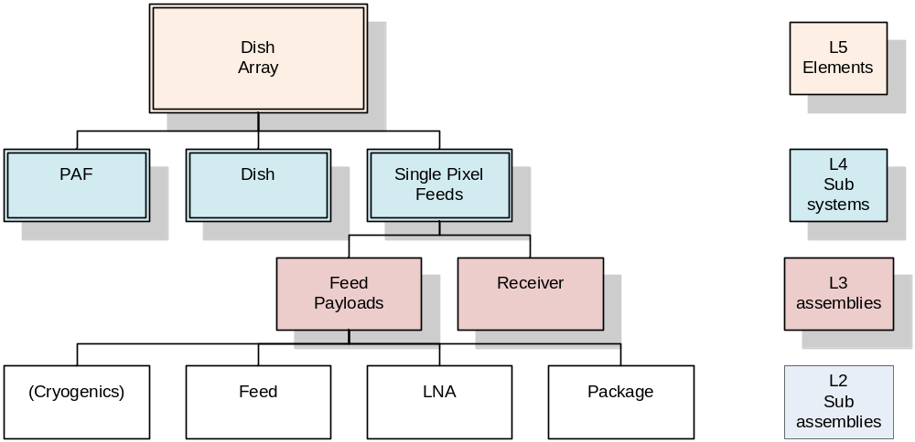
Figure 1 Dish Array Hierarchy
This document describes one family of options for the level 3 system assembly, the PAF receiver.

3.2 Role of PAF Receiver Assembly in the Dish Array
This concept is applicable in the case where PAF receivers are implemented as part of the SKA’s dish feed array.
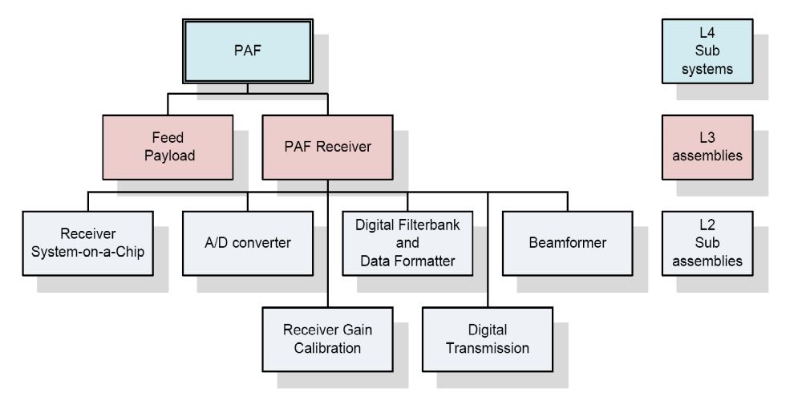
Figure 2 PAF Sub-system Hierarchy
The PAF receiver using an integrated IQ mixer architecture is a receiver assembly that can be used with a variety of phased array feed sub systems delivering multiple beams, wide FoV and high survey speed. Digitised signals from a number of antennas could be sent either to the central site, or to centralised RFI shielded “bunkers”, where the signals are digitally processed. The PAF receiver using an integrated IQ mixer architecture addresses the functional and non-functional requirements for a high survey speed for the SKA; many of these requirements are unique and go far beyond what has previously required for ground based radio astronomy.

Physical Description
Provide a description of the proposed sub system, with diagrams, CAD drawings, photographs etc. Include details of how the sub system will interface with other parts of the Dish Array.
This PAF receiver assembly concept includes the following:
- An integrated “Receiver System-on-a-Chip” that includes RF gain, RF filters, I/Q direct quadrature down conversion, IF gain and anit-aliassing filters.
- Analog-to-digital conversion using the EV8AQ160 or similar,
- Gain calibration to correct for minor variations in gain and phase of the RF channels,
- Digital Filterbank signal processing and data formatting for transmission to the Beamformer.
- Transmission of the Filterbank digital output to the Beamformer over optical fibre,
- Digital processing in the Beamformer, and
- Digital transmission within the Beamformer using optical fibre.
Figure 3 is a block diagram showing the key components and where they will be housed and Figure 4 shows the topology of a cross connected beamformer.
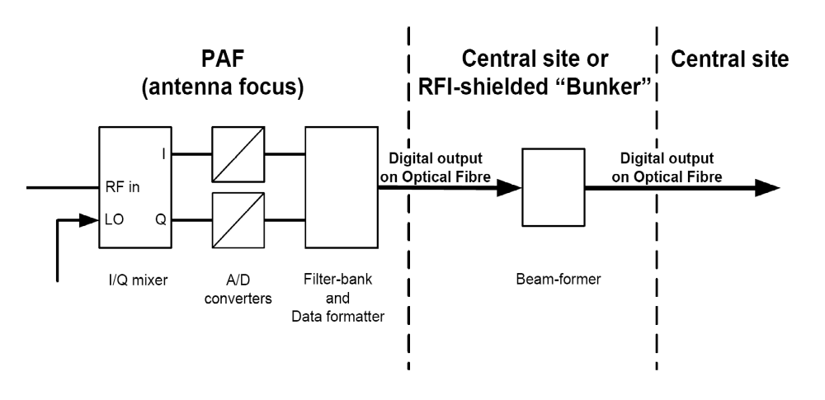
Figure 3 PAF receiver using an integrated IQ mixer architecture
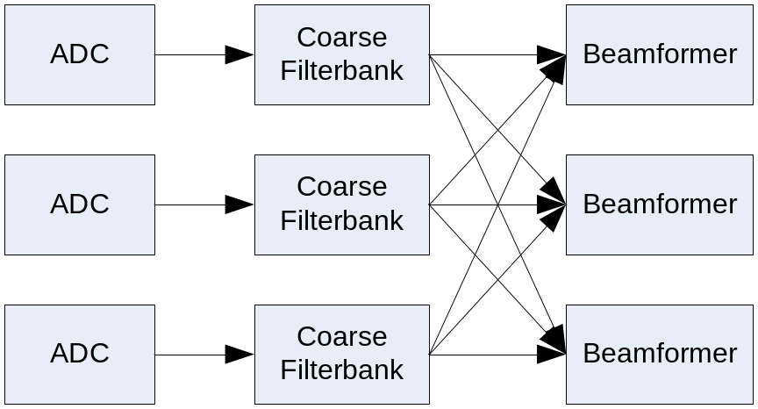
Figure 4 Topology of a cross connected beamformer
The first two blocks shown Figure 4. – the ADC and the Coarse Filterbank – will be located in the PAF package. Digital transmission over optical fibre will provide the connection between the Coarse Filterbank and the Beamformer.
A feature of this option is that it allows digitisation of the received signals at the antenna and the beamformer digital processing to occur up to, say, 10 Km from the antenna. Thus the beamforming of the signals from the antennas in the “core” and “inner” regions (for SKA Phase 1) could be at the central site; for antennas in the “Mid” region, the processing of signals from one or more “clusters” of antennas could be centralised in RFI shielded “bunkers” and the beamformed outputs trunked to the central site.
A local oscillator is required, and tuning is achieved by adjusting the frequency of the local oscillator. Note that, when we use I/Q frequency down-conversion, there is a gap in the observing band near the LO frequency and we require excellent matching (gain and phase) of the I and Q paths.
It is planned to use a sample clock that is above the highest observing frequency. For an observing band of 600 – 1500 MHz, we would use a sample rate of 1600 MS/s. The IF bandwidth is selected after the Filterbank by transmitting only the required IF frequency channels.
Note that the poly-phase filter that follows the ADC must operate at the clock rate of the ADC but at the output of the filterbank the frequency channels to be processed in the beamformer and correlator can be selected. In this design antialiasing filters with relaxed specification for the transition band are used. This allows low cost filters to be used. A filter achieving 40 dB alias rejection at the edge of a 450 MHz pass band with a 1600 Msps ADC could be achieved with a simple 4 pole Chebychev filter with 1 dB passband ripple. This scheme allows us to instantaneously sample the entire RF range of 600 – 1500 MHz using two relatively low speed ADCs. After the filterbank, frequency channels that are outside the filter cutoff can be discarded. The data at these frequencies is discarded at the output of the filterbank.

Integrated Receiver “System-on-a-Chip” subassembly
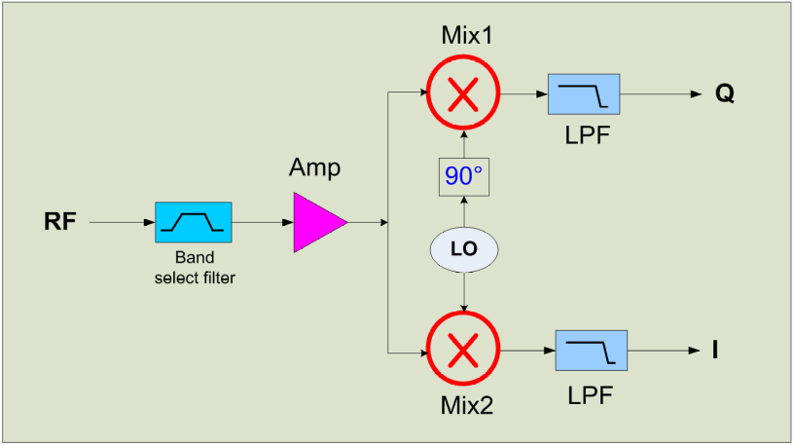
Figure 5 I/Q frequency down-conversion and sampling at IF
The critical CSIRO/Salinna Silicon-on-Sapphire chip specifications are:
- 250 MHz to 2500 MHz RF range.
- Onboard by-passable RF filters – 700 MHz HP and 1200/1800 MHz LP.
- 2 dB input noise figure.
- I/Q direct quadrature down conversion - selectable instantaneous bandwidth up to 600 MHz.
- 40 dB dynamic range due to tight I/Q amplitude and phase matching
- Onboard LO synthesiser and ADC driver.
- Plenty of RF and broadband gain adjustment:
- 14 – 39 dB RF gain range, 5 dB steps.
- 8 – 20 dB BB gain range, 2 dB steps.
- Compact 6 mm square QFN package.
- Low power (target < 5 W).
The CSIRO/Salinna Silicon-on-Sapphire chip is described in greater detail in Jackson et. al. [SJ1]
[SJ1] Suzy A. Jackson, Russell G. Gough, and Yashodhan Moghe, “Receiver Integration for Mid-band Square Kilometer Array Demonstrator Applications”, 2010 IEEE Compound Semiconductor Integrated Circuit Symposium, Monterey, CA USA, October 3-6, 2010

Analog-to-digital conversion subassembly
Examples of analogue to digital converters that meet the specification for a PAF are the EV8AQ160 and EV10AQ190 manufactured by E2V. Critical specifications for these are list below. Converters from other manufacturers are also suitable and, as time progresses, it is quite likely more options will become available.
For the example EV8AQ160 Analog-to-digital converter the critical specifications are:
- 8-bit;
- 7.2 ENOB;
- 4 samplers interleaved in one chip;
- Max. Sample rate in dual channel mode: 2.5 GS/s;
- Max. input Freq 2GHz (typ.), 1.5 GHz (min.)

Max. Sample rate (MHz) | Input bandwidth (MHz) | interleaved
1250 | 600 | 1
2500 | 1200 | 2
5000 | 2000 | 4
Table 1. EV8AQ160 Analog-to-digital converter

Receiver gain calibration subassembly
Receiver gain calibration subassembly uses noise radiated from the dish surface or rim to measure and track the relative complex gains of the individual receiver channels from the low-noise amplifier through to the digitiser. A sample of the radiated noise is also digitised using a spare channel of the receiver. The sample of the radiated noise is correlated with the output of each of the RF channels to measure and track the relative complex gains of the individual receiver channels. The relative complex gains of the individual receiver channels are used to adjust the weights fed to the beamformer and thus compensate for channel gain and phase variations.
This calibration system will naturally measure, and compensate for, gain and phase variations in the RF electronics and in the RF-over-Fibre links – in bandwidths corresponding to the output channel bandwidth of the Poly-phase filters.

Digital Filterbank and data formatter subassembly
After the analogue data is digitised it is processed by Digital Filterbank and data formatter subassembly. The Digital Filterbank and Data formatter for the output optical signal will be in the same FPGA. Each Digital Filterbank is ultimately connected to each of the beamformer boards and for N beamformer boards the data on each connection carries data for 1/N of the frequency channels being processed.

Digital transmission over optical fibre
Digital data would be transported out of a shielded enclosure on optical fibre. Long distance transmission would require the use of single-mode fibre optics.
For distances up to 10 km – to the central site for antennas in the “core” and “inner” regions (for SKA Phase 1) and signals from antennas in one or more “clusters” – SFP+ transceiver modules are available at 10 Gbps. MSA SFP+ modules 1310nm 10GBASE-LR are currently ~AUD 200 each in volume.
SFP+ modules utilise standard physical contact LC connections and suitable ribbonising techniques are required to interface multiple 10G SFP+ modules to a ribbon cable pipeline. A 12-way conversion from LC fan-out to 12-way ribbon unterminated is ~AUD 100 in volume. SFP+ modules only have Rx and TX electro-optical components. Data stream framing, clock and data recovery (CDR) can be implemented with appropriate VLSI chipsets or be part of signal processing FPGA logic.
The Digital Optical Transmitter will include the electrical-to-optical transducer and output optical connectors.
It is not clear how this overlaps with Signal Transmission and Networks (STaN) responsibilities.

Digital Beamformer subassembly
For the Phase 1 SKA beamformer, multiple processing boards are needed for the beamformer and a cross connected beamformer is used. Refer to Figure 4.

Digital transmission within the Beamformer
Digital data would be transported within the Filterbank/Beamformer shielded enclosure on optical fibre. Currently the cheapest method of transporting digital data over short spans, ie very short reach (VSR) on fibres is with the use of 12 fibre optical cables illuminated by 12 element optical transmitters such as the industry standard SNAP12 modules [SNAP12 specifications http://www.physik.uzh.ch/~avollhar/snap12msa_051502.pdf]. These are well suited to massively parallel data transfer applications such as BF to COR connects.
SNAP12 modules are currently ~AUD 250 each in volume and are estimated to fall to under $100 by 2017. Modal dispersion would limit the distance of these inherently multimode 50um core 850nm wavelength devices based on cheap VCSEL optical transmitters.
The use of appropriate fibre such as OM4 Corning Infinicor eSX+ extends the Effective Modal Bandwidth (EMB) from 500 MHz.Km to 4700 MHz.Km.

Output Digital Optical Transmitter
Beamformed outputs from the RFI shielded “bunkers” will the trunked to the central site using longer distance variants: 10BASE-ZR at 1550nm will be capable of 80 km in standard G652 fibre will be available for ~AUD 2000 each in volume.
The Data formatter for the output optical signal will be included in the Digital Beamformer. The Digital Optical Transmitter includes only the electrical-to-optical transducer and output optical connectors.
It is not clear how this overlaps with Signal Transmission and Networks (STaN) responsibilities.

Requirements
This section of the document will describe how the proposed sub system will address the requirements for the Dish Array, which are derived from the system requirements and ultimately the science requirements. These include both the functional and non-functional requirements. Some of the key requirements that need to be addressed are as follows.
- Imaging dynamic range
- Mass manufacture
- Operating cost
- Feed flexibility (dishes)
- Rapid installation
- Maximising A/T per unit system cost (i.e including signal transport, signal processing, computing etc.)
- Maximising survey speed per unit cost (PAFs)
- Minimising maintenance cost
- Electromagnetic compatibility

Functional Requirements
Describe which requirements are being addressed and how the proposed sub system is expected to meet them. For example, how will the octave band feed payload optimise the Dish Array pulsar observations capability, or how will the proposed PAF option optimise HI surveys?
Input/advice from Lisa?

Imaging dynamic range
High imaging dynamic range for PAFs is yet to be demonstrated. Imaging dynamic range is largely independent of the PAF receiver assembly concept but depends critically on the accuracy of the Receiver Gain Calibration subassembly..
Are there any compromises to DR which the receiver might implement (number of bit samplings?)

Feed flexibility (dishes)
Feed flexibility is not applicable to the PAF receiver assembly concept.
Agree, but perhaps more important to outline which components of the receiver system can be housed where & what flexibility there is (if any) of what to put where.

Rapid installation
Rapid installation is not applicable to the PAF receiver assembly concept.
No- but it is important that PAF receivers have accessible components which don’t take 4 days to extract one failed part. Modularity? Murandi ideas?

Minimising maintenance cost
The PAF receiver assembly will be designed to minimise maintenance costs.
How? What are the major traps we know of, is this very costly to mitigate?
What about looking at the closest commercial PAF (defence) who have solved this problem? (e.g. L3 products)
Do we put more $’s into expensive parts up-front? Build more self-test systems? Diagnose whilst the system is in the pedestal rather than having to remove cards/racks?
Tolerance to environment – heat, cold? Water/dew? (see 5.2.5 System Environmental Requirements)
Graceful degradation?

Reliability
The entire SKA receiver system will be field repairable to the level of tested sub-assemblies. No manufacturing, assembly or installation processes should be employed that would preclude field replacement of sub-assembly level systems or components.
The antenna reliability is defined by the observatory uptime requirement: no more than 1%?? of the antennas (of the complete SKA array) offline at any one time. This translates to a MTBF of 20000?? hours for the receiver system. The time to repair any single antenna fault should not exceed one day.
The SKA receiver system should be designed to require little hands-on maintenance. The interval between site visits by a technician to carry out any preventative or routine maintenance activity (including inspections) should not be less than 12 months ??? .

Electromagnetic compatibility
The PAF receiver assembly will be designed for electromagnetic compatibility.
Stringent efforts will be taken to ensure that local oscillator signals, sampler clocks and digital noise from the Filter-bank and data formatter do not radiate.
And…?
What about mitigating self-interference? What are the noisy sources in this system? How can they be tested? Are they reliable or do they vary by T?
The SKA site has been chosen as it is virtually free of any terrestrial radio frequency interference The SKA receiver assemblies are to be designed to preserve the RFI environment at the SKA site, and this requires that all sources of RFI are to be shielded and made RFI-tight. As far as possible all components of the receiver are to be housed in RFI-tight cabinet(s). The cabinets are to meet the requirements of RFI/EMC shielding to provide electromagnetic attenuation better than 80 dB between 10 kHz and 1 GHz, tested as per IEEE-STD-299. All components of the receiver are to be certified by a qualified testing laboratory to meet the MIL-STD-461F standards ( RE102; In figure RE102-4 the limits for "Navy Mobile and Army" are applicable) over the frequency range 0.3 to 1.8 GHz.

Non-Functional Requirements
There are many non-functional requirements that will need to be met if the Dish Array is to operate successfully; a few of these are listed above. Describe here how some of the critical requirements are expected to be met. For example, how will it be mass-manufactured to minimise cost, whilst maintaining reliability; how will the maintenance cost be kept to a minimum?

Mass manufacture
The PAF receiver assembly will be designed to be mass-manufactured and to minimise the SKA system cost, including operation and maintenance.
ASTRON has much experience and many ideas to include here.
What about Murandi’s ideas?
Is there a case to chose one receiver architecture over another at this point? Is it easier to build I rather than 2?

Operating cost
The PAF receiver assembly will be designed to minimise the SKA system cost, including operation and maintenance.
Power? Which parts/components are power hungry? Temperamental?
The challenging conditions at the SKA site put a premium on minimising operational power consumption.

Maximising A/T per unit system cost
The PAF receiver assembly will be designed to minimise the SKA system cost, including operation and maintenance thus maximising A/T per unit system cost. (i.e including signal transport, signal processing, computing etc.)
Indicative figures – we don’t want to quote ASKAP verbatim but how about some projections?

Maximising survey speed per unit cost (PAFs)
The PAF receiver assembly will be designed to minimise cost thus maximising survey speed per unit cost.
This needs to be well argued at this point – need Lisa’s (and others) analysis here.

System Environmental Requirements
The receiver system will be designed for reliable operation at the site where the normal operating conditions are :
- Ambient T in the range -10 to +55 degrees C.
- The mean daily solar exposure ranges from 30 MJ/m2 (summer) to 13 MJ/m2 (winter).
Lightning protection is to be built into all components of the receiver system.
In average conditions, there is a significant amount of fine airborne dust (sand): all parts of the receiver system are to be suitably designed to prevent ingress into interior areas or mechanical parts, and minimise build-up on external surfaces.
All exposed parts of the receiver system are to be water-tight and vermin proof: In wildlife may destroy any material known to mankind.

System Operational and Quality Requirements
The challenging conditions at the SKA site put a premium on a number of design considerations for the SKA receiver system:
- Reliable and safe operation consistent with unattended operation.
- Every aspect of the receiver system is to be designed with the site restrictions in mind: The SKA needs to be able to maintain and repair the receiver equipment with limited engineering resources and personnel.

Technical Progress to Date
Give a brief description of development work to date, together with critical results where appropriate. More substantial reports on technical progress can be included as appendices.
Summarise PAF receiver technical progress to date viz. development of RF over fibre and direct RF sampling.
CSIRO to do.
Other partners – particular areas to contribute to be identified.

Cost Estimates
Provide initial cost estimates for manufacture of the proposed sub system in quantities applicable to the SKA phases 1 and 2.

Plans for Further Development
Describe the plans to further develop the proposed sub system up to the point where it can be mass manufactured. Include time lines and details of resources that will be available to carry out the work.
Summarise plans for further technical development of key technologies viz. development of RF over fibre and direct RF sampling.
Again – to be identified as soon as possible & start assembling this section.
Sillana design etc.
Junk


