ATNF ATUC Memorandum

To: ATUC
From: Lister Staveley-Smith
Date: September 26, 2004
Subject: Recent Astrophysics highlights

Recent Astrophysics highlights

- Carbon Monoxide in High-Redshift Galaxies

One of the first observing programs to be scheduled with the full complement of new 3-mm receivers in September 2004 was, paradoxically, a search for CO emission in a z=5.2 radio galaxy, TN 0924-2201 (Klamer et al.). Amazingly enough, this observation resulted in a 3-sigma detection of the redshifted CO (5-4) transition which lies at a frequency of 92.9 GHz (Fig.1). The observation involved a substantial amount (35 hours) of integration time. Although not a totally secure result in its own right, earlier observations were able to detect the redshifted CO (1-0) transition at 18.6 GHz (Fig.2).

Figure 1: CO (5-4) emission from the radio galaxy TN 0924-2201. The observations were taken in 2004 September with the Compact Array at 93 GHz. The velocity axis is with respect to the Ly-α derived redshift of 5.1989. The data is averaged into 30 km/s bins. The rms noise level is shown at the top left (Klamer, Ekers, Sadler, Weiss, Hunstead & De Breuck, to be submitted).

Figure 2: CO (1-0) emission from the radio galaxy TN 0924-2201 (solid line) with the CO (5-4) emission from Fig.1 overlaid. The (1-0) observations were taken in 2004 August/September with the Compact Array at 18.6 GHz. The velocity axis is with respect to the Ly-α derived redshift of 5.1989. The (1-0) data is plotted in 32 km/s bins. The rms noise level is shown at the top left (Klamer, Ekers, Sadler, Weiss, Hunstead & De Breuck, to be submitted).

- Dense Molecular Gas Heated by Starburst Galaxies

Cyanide chemistry is an important process in dense (>10⁴ cm⁻³) molecular clouds whose presence in galaxies is tightly correlated with star-formation rate. This chemistry is well traced by the (1-0) transitions of the HCN and HNC molecules which emit at 88.6 and 90.7 GHz, respectively. First results for the nearby starburst galaxy NGC 253 from Compact Array observations are shown in Fig.3 (Ott et al.). These are the first interferometric HCN,HNC images of an extragalactic system. Close to the NGC 253 starburst nucleus, the HCN/HNC ratio is about unity. Further out, as in the Milky Way and other non-starburst galaxies, HCN dominates. We speculate that either the optical depths are getting larger toward the nuclear starburst or, alternatively, that the chemistry changes with the distance to the starburst center. HCN and HNC are produced in equal quantities by ion-neutral reactions. Further away from the starburst, where less material is ionised, neutral-neutral reactions probably have a larger influence converting HNC + H into HCN + H, resulting in HNC depletion. These observations therefore suggest that the HCN/HNC ratio may be an indicator of massive star formation.

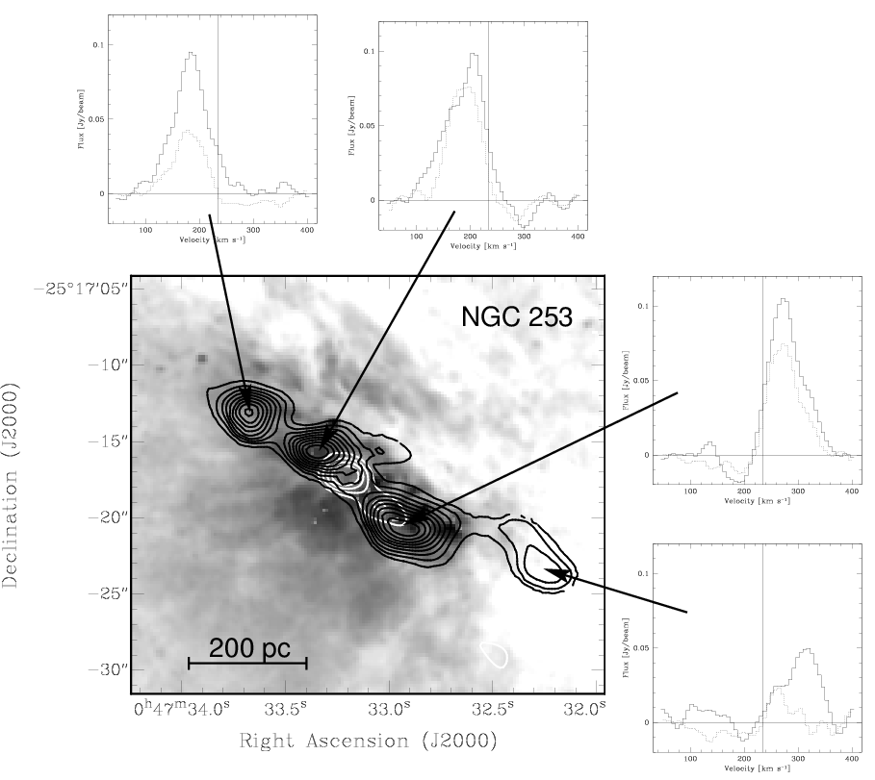

Figure 3: Contours (black) of HCN emission in the starburst galaxy NGC 253 overlaid on an HST/WFPC2 image taken with the F814W filter. The white contours are the 3mm continuum. In the spectra the solid lines are HCN and the dotted lines are HNC. Observations by Ott, Henkel, Weiss & Walter.

- The Galactic All-Sky Survey (GASS)

The next generation Parkes HI multibeam survey is the Galactic All-Sky Survey (GASS; McClure-Griffiths et al.) whose aim is to survey the southern sky in a similar manner to HIPASS, but concentrating on HI emission at Galactic velocities and at velocity resolutions of ~1 km/s instead of the 18 km/s of HIPASS. The primary aims are to study the disk-halo interface, to study the nature and origin of High-Velocity Clouds (HVC), to look for evidence of tidal streamers from infalling dwarf galaxies, and to map the distribution of the recently-discovered population of cold halo clouds. Pilot observations to test scanning strategies are now complete (see Fig.4) and it is planned to embark on the full-scale survey. It is hoped to increase the correlator power available by combining the multibeam correlator with the wideband correlator so that all 13 beams can be utilised.

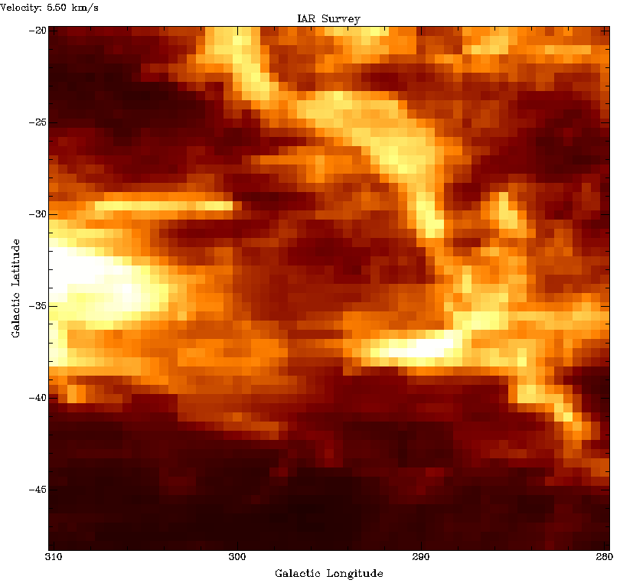

Figure 4: (Left) Test image at LSR velocity 5 km/s of a portion of the Galaxy in front of the Large Magellanic Cloud from the Galactic All-Sky Survey (GASS) at Parkes; (right) a similar region from the IAR survey of Bajaja et al. Although processing is preliminary, the improved sensitivity and resolution of the Parkes data is evident (McClure-Griffiths et al.).

- The Australia Telescope 20 GHz (AT20G) Survey

The ATCA 20 GHz (AT20G) survey has entered its second year and has now completed the declination range –30 deg to –50 deg, which comprises 27% of the southern sky. These observations were done in 2004 August, during the period in which the millimeter systems were due to be installed. 3800 candidate sources were detected, of which 1700 were later confirmed at 20 GHz and had flux densities measured at 5 and 8 GHz. Many rising spectrum sources were detected, a high percentage of which are distant QSO’s such as the z=2.8 quasar PKS 2151-386 (Fig.5), which has a flux density of 150 mJy source at 20 GHz. Preliminary data from AT20G has been used to establish the 20 GHz source counts and the likely contribution of high-frequency sources to maps from the Planck surveyor (Ricci, Sadler et al. MNRAS 354, 305).

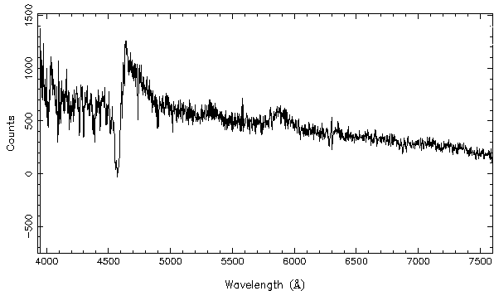

Figure 5: The 6dFGRS spectrum of the quasar PKS 2151-386 which was detected as a 150 mJy source in the AT20G survey. The quasar has a redshift of 2.8. Prominent Ly-α emission at 4600 Å and CIV at 5900 Å can be seen, as well as damped Ly-α absorption blueward of the emission peak.

