ATNF ATUC MEMORANDUM

To: ATUC
From: Bob Sault
Date: 4 June 2005
Subject Narrabri operations report

Duty astronomer system and remote observing
Following on from the December ATUC meeting, the duty astronomer scheme use to help support the ATCA has been changed. The aim of the change is to provide our observers with a more experienced duty astronomer, and a duty astronomer who is accountable to the ATNF. In detail
- DAs will be drawn from AT staff or ATNF co-supervised students with at least 12 months PhD experience.
- Experienced non-ATNF astronomers may serve as DA, but only with the prior approval of the ATNF Director.
- All DAs will be familiar with their expected duties prior to arrival at the telescope.
- All new DAs or DAs lacking recent experience (more than nine months since their last visit) should:
- arrive at the telescope at least 24 hours prior to the official start of their DA period and during this time they should
- receive a detailed induction during this time from a member of the telescope staff with appropriate knowledge of the current system relevant to the observations to be undertaken during the DA period
- liaise closely with the current DA
- All other DAs should:
- attend the telescope at least 12 hours prior to the official start of their DA period during this time should:
- liaise closely with the current DA
- All DAs will be required to demonstrate knowledge and understanding of all items on the current version of the DA checklist to the OIC or his/her delegate immediately prior to the commencement of their DA run.
- Immediately prior to the completion of their DA period, the DA should complete a handover report and provide a copy to the incoming DA.

This changed scheme came into operation on 1 April. It is too early to conclude whether there has been any change in the quality of the duty astronomers.

ATUC also requested that the requirement that the requirement for remote overseas observers to perform duty astronomer duty be dropped. This was a natural consequence of the change in the duty astronomer scheme, and was also implemented from 1 April.

Part of the rationale of the previous system for duty astronomers and remote overseas observing was to ensure that there are a healthy number of astronomers visiting the observatory. This benefits both the observatory staff and the visiting observers. On the one side, the staff benefit from a diverse mix of visiting observers who bring with them new approaches and ideas. On the other side, the visiting observers can refresh their expertise on the instrument and gain a better appreciation of the new developments. Requiring overseas astronomers to visit the observatory is also seen as a useful way to ensure that Australia continues to attract overseas astronomers. Additionally by requiring overseas observers to visit the observatory, it is possible for them to make a stronger case to their funding bodies for travel support to Australia.

The changes in the duty astronomer system and the overseas remote observing rule are likely, in themselves, to reduce the number and diversity of visitors to the Observatory. As a counter to this, a new requirement is that observers must observe in person at Narrabri at least annually to remain eligible for remote observing.

ATCA 3mm developments
Since the end of the 2004 millimetre season, substantial progress has been made on improving the overall functionality of the 3mm system.

A problem of low gain on antenna 1 has been resolved. The low gain was a result of under-engineering of the subreflector in the original design coupled with work on the subreflector actuation. During March, axial and lateral adjustments have been made to optimise the subreflector position on a number of antennas. In part driven by work for NASA, the so-called “second derivative” problem of the phase rotators (a problem that has been known about for many years) has been properly understood and resolved. Measurements of the local oscillator stability show that it is excellent. (< 3° rms phase noise at 86 GHz). With all five antennas now showing good gain, reference pointing is now much more robust. There have been a number of improvements to on-line and off-line software to simplify handling 3mm observations.

The seeing monitor is working reliability, with its output now available on the web. Tools to give additional parameters describing atmospheric phase stability are also now available on the web.

On the hardware side, a new 3mm low noise amplifier was installed into one antenna (CA04 channel B). This is now by far the best LNA in the system, with system temperatures down to 170K. Amplifiers in the millimetre conversion chain have also been replaced. This has helped to make the power across the system more uniform, which in term simplifies attenuator setting. This had also helped make the system temperature measurement scheme (paddle calibration) more robust. The second set of 16 MHz filters is on track to be installed before the observation that requires them.

Below is a plot of system sensitivity across the 3mm band. As can be seen, the best sensitivity is at 93-95 GHz.
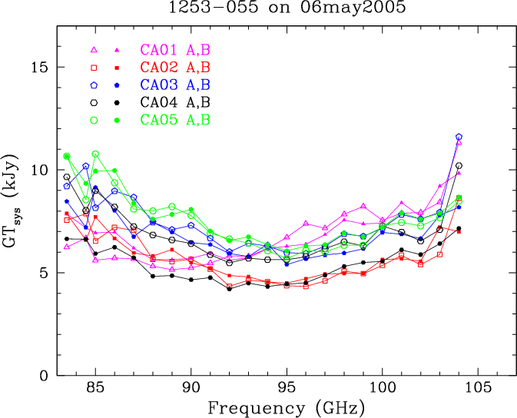

Figure 1: ATCA system sensitivity at 3mm (courtesy Tony Wong). This gives the strength of an astronomical source required to double the system temperature.

On the operational side, the flux density of about 120 “bright” 3mm calibrators were re-measured in May. These measurements have been included within the ATCA calibrator web search engine. During the 2005 season, on a monthly basis, the flux density of the calibrators 1921-293 and 1253-055 will be measured using Mars and Uranus as primary flux standards. As a consequence it will be possible for a number of observing projects to use measurements of 1921-293 and 1253-055 as flux standards rather than the planets.

There are still a number of avenues being worked on to improve the utility of the 3mm systems. These include better understanding some instrumental phase errors, installing an opacity meter, improved pointing models, improved understanding gain/elevation effects (this may be affected by temperature), and further enhancements to the on-line and off-line software. Another recent issue has been the tuning of the antenna drives: the drive systems are complex feedback systems which require regular adjustment to keep them performing well. For some azimuths, at some times, the tracking errors that are being experienced on some antennas are significant fraction of the primary beam at 3mm.

Another area of development at Narrabri is the porting of the observing system to a LINUX environment. This is now in its final stages, with the new system being offered to “friendly observers”. It is anticipated that the switch to this as the normal system will be in July or August. If you are at Narrabri, we invite you to volunteer to try the new system.

Advice sought
- ATUC is invited to make suggestions to help optimise the duty astronomer and remote observing schemes, to maximise the interaction between astronomers and observatory staff, and to assist in encouraging overseas observers to visit Australia.
- ATUC is invited to comment of further measures to help maximise the science coming from the 3mm systems.

