The ATNF S2 Data Acquisition System
Preface to ftp/pdf File

This document derives from a paper presented at the fourth Asia-Pacific Telescope meeting and workshop in December 1995 and published in the Proceedings. It has been updated to provide a general introduction to the style and capabilities of the LBA DAS in its mature form.

Dick Ferris 7/12/98

The ATNF S2 Data Acquisition System

Dick Ferris
Australia Telescope National Facility

Abstract

The DAS provides two independent signal channels with broadband inputs at IF, and outputs in S2 and correlator formats. One or two passbands may be assigned to each channel. Output bandwidths range from 64MHz down to 62.5kHz in factors of two. Passbands 16MHz and below may be tuned in 1Hz steps. All processing is based on digital filter technology.

Background
• Very different receiver systems at each telescope in the LBA.
• Telescopes spend only a small percentage of time on VLBI.
• Autocorrelators available at six out of eight LBA telescopes in the near future.
• DAS design provides fully featured narrowband backend for single dish operation.

Configuration (Fig. 1.)
• Two IF system, eg LCP + RCP.
• Independent bandwidth selection.
• One or two passbands per IF.
• Fine tuning for bandwidths 16MHz and less.
• Two-bit digitisation at output with integral statistics normalisation.
• S2 Port : direct connection to C1 cable. AT, Multibeam and VLBA format data.
• Correlator Port formats 1) AT (2-bit / 4-level)
2) Multibeam (2-bit / 3-level)
• Analog Ports : signal reconstructed from high resolution data for spectrum monitor, special backends etc.
• Digital Port : high resolution (10-bit / 1024-level).
• Full computer control and monitoring.
• No manual run-time controls.
• Basic control software provided for PC in ANSI C.
• High level control software incorporated in PCFS (under development).

Hardware (Fig. 2.)
• Fully contained in 5U 19" rack bin.
• N2 + N3 module for each channel, D3 computer interface, N4 power.
• Choice of RS485/422 and RS232 computer interfaces.
• 115/240V, 50-60Hz mains power.
• Internal cable compensation for 1PPS and 5MHz reference.

Signal Path (Fig. 3.)
• Broadband IF input; 144-172MHz used for outputs.
• Alternative prefiltered inputs at 0-64MHz, 64-128MHz or 128-192MHz where available.
• Alternative 64MHz BW digital data input where available, eg. AT Tied Array.
• AGC amplifier compensates for +/- 6dB changes in IF input level.
• Unlike analog systems, 'sampler' is an 8-bit ADC, and precedes the filters.
• 5MHz reference frequency provides 128MHz for the ADC and 32MHz for the processor clock.
• 1PPs synchronises output data and allows phase-continuous frequency switching.
• Raw ADC output, (up to 64MHz BW,) is available at the correlator and S2 ports.
• Bandpass filtered data 32MHz BW and down is available at the correlator, S2 and analog ports.
• High resolution bandpass filtered data 16MHz BW and down is available at the digital port.
• Single Passband Mode: 32MHz down to 1MHz BW, all centred on the middle of the input band.
• Dual Passband "BBC" Mode: adjacent USB+LSB pairs, 16+16MHz down to 1+1MHz, "DC" at midband.
• Tuned Passbands: additional filters, single or dual passband mode, tuned across any fixed band <= 16MHz.
Output BW is equal to or 1/2 down to 1/16 of the tuner input BW.
Narrowest bandwidth is 62.5kHz.
Tuning resolution is 1Hz across the input band.
Frequency switching is phase continuous and synchronised to 1PPS.
• Mixed Passband Mode: one ('broad') fixed passband and one ('narrow') tuned passband.
• Dual Split Bands (Fig. 4.): non contiguous passbands in many forms may be programmed if required.
• Spectrum inversion at will for any output data stream.

Recorder/Passband Options..(Fig. 3., Table 1.)
• Some common modes not exceeding 128Mbps (S2 capacity) and their applications.
• Telescopes providing 64MHz prefiltered inputs may see 64MHz at the correlator and S2 port.

Why Digital Filters?
• Engineering: Completely deterministic.
• Avoid : Component selection
Signal balancing
Elaborate alignment procedures
• Instead : Easy design
Exact modelling
Precise performance
• Astronomy: Stability, performance.
• Amplitude, phase and group delay responses as stable as the hydrogen-maser standard derived clock signal!
• Reduced closure phase and amplitude errors, increased sensitivity.
• Wider, flatter passbands.
• Near-perfect passband matching between systems.
• Nil dispersion/group delay distortion across the band.
• Common sampler eases calibration problems in multiple band (‘hybrid’) correlations.
• Flexibility allows many different functions from common hardware.
• Cost effective for high performance multiple response systems.

-------------------------------------------------------------------------------------------------------------------------
file: ats2prnt.doc rev:7/12/98 printed 30/07/26 14:38

Figure 1.

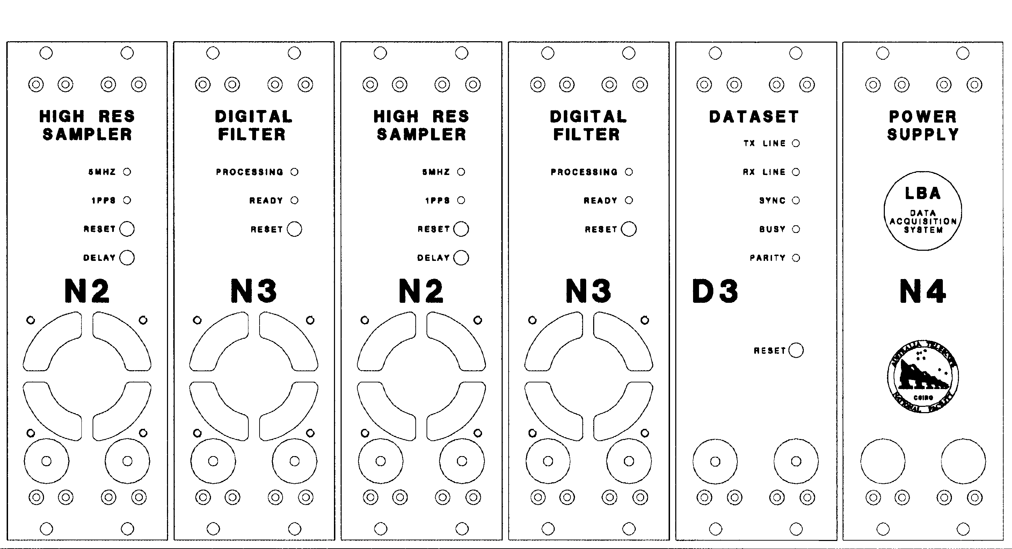
LBA DAS Bin Figure 2.

Figure 3.

Figure 4.

A Selection of LBA DAS to S2 Options

Filter Response #1 | Mode/Data for 2 IFs | Data for 1 IF
 | n.a.  Pulsar  32MHz @ 1bit  LBA continuum  16MHz @ 2bit  8MHz @ 2bit  4MHz @ 2bit  2MHz @ 2bit  1MHz @ 2bit  n.a.  RadioAstron & VLBA  2 * 8MHz @ 2bit  RadioAstron, VLBA, MkIIIA  2 * 4, 2, 1MHz @ 2bit  Line plus continuum #2  2 * BMHz @ 2bit #4  b = B/2MHz tunable  B/4MHz tunable  B/8MHz tunable  B/16MHz tunable  VLBA, MkIII & RadioAstron  2 * B/2MHz @ 2bit #3  2 * B/4MHz @ 2bit tunable  2 * B/8MHz @ 2bit tunable  2 * B/16MHz @ 2bit tunable | 64MHz @ 1bit  VSOP  32MHz @ 2bit  16MHz @ 2bit  8MHz @ 2bit  4MHz @ 2bit  2MHz @ 2bit  1MHz @ 2bit  VSOP  2 * 16MHz @ 2bit  2 * 8MHz @ 2bit  2* 4,2,1MHz @ 2bit  2 * BMHz @ 2bit  =  =  =  =  =  =  =  =

#1 Band edge frequencies correspond to 64-128MHz input #3 +/- B/32MHz max. tuning recommended.
#2 The BMHz subbands may be interchanged at will. #4 B <= 16MHz only. Case b = B/1 not shown.

